27 July 2021

- alert (“Hello world!”) – Enter

- ‘if’ commands

- using JS as a calculator

- What is Javascript?

* High level, object oriented, multi paradigm programming language
  + Programming language – the language that computers speak in
  + High level – complexities are hidden
  + Object oriented – based on objects for storing data
  + Multi paradigm – different styles (structuring code) of programming is applicable

- Why use Javascript?

* The Three Pillars – html, CSS, javascript
  + Html – content – text, photos, links etc
  + CSS – aesthetics / presentation
  + Javascript – programming language to build web applications
* Dynamic effects – application through Twitter example
* Libraries / tools such as React/Angular/Vue frameworks – makes modern, large scale dev. easier, but is based fundamentally in Javascript
  + Libraries might disappear, but Javascript would remain as the foundation
* Outside of browser application / web applications on web servers – nodeJS
* Native mobile / desktop applications – ReactNative, Ionic, electron
* Javascript releases - ECMAScript
  + ES5
  + ‘Modern Javascript’
    - ES6 - 2015
    - ES11 – 2020
  + Jonas msg – **learn modern Javascript from the beginning**
* Console.log(40+8)
  + Explicit instruction for JS to know to display the mathematical calculation into the browser console
* ‘Values’ – a piece of data
  + Declaring variables –
  + *let* firstName = 'Jonas';
  + Conventions
    - Camelcase
      * firstName
      * firstNamePerson
      * first_name_person
    - Must start with a letter
    - Space around operators (= + - * / ,)
    - Legal symbols - Numbers, letters, underscores or $
    - Reserved Javascript keywords – ‘new’, ‘function’, ‘name’
    - Do not start with uppercase letter
    - The variable name should make sense and give a hint to what data is being contained
* A Value can either be: a) an object or b) primitive data
  + 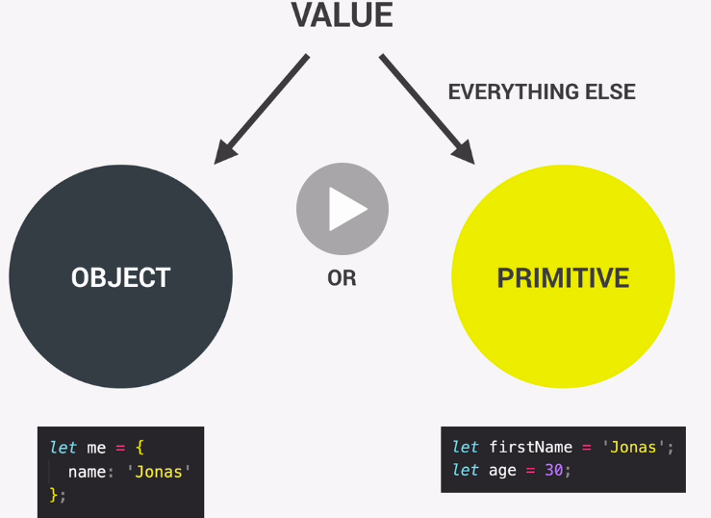
* The 7 primitive data types
  + Number (floating point numbers) – used for decimals, integers
    - Let age = 23;
  + Strings (sequence of characters) – used for text, *must be enclosed in quotation marks* otherwise they get confused for variables
    - Let firstName = ‘Jonas’;
  + Boolean (logical type that can only be true or false) – used for taking decisions
    - Let fullAge = true;
  + Undefined (empty value placeholder)
    - Let children;
  + Null (also empty value placeholder)
  + Symbol (unique and cannot be changed)
  + BigInt (larger integers than the Number type can hold)
* Dynamic typing – to use a data type, you do not have to declare explicitly what the type of each data point needs to be
  + It is the value that has the type, not the variable
  + Variable X can be a string or later converted into a number
* Commenting in JS - // or control + /, /* and */
* Figure out what the data type is – typeof
* Changing the value of an already existing variable
  + Let javascriptIsFun = true;
  + javascriptIsFun = ‘YES!’
* Declaring variables that store ‘undefined’ values and displaying to console
  + Undefined can be both the *type* and *value*
* Console.log(typeof null);
  + Javascript weirdly declares null as an ‘object’ type
  + Legacy bug
* Let, const and var
  + Let – variable declaration
    - Variable reassignment or muted – changing the value after declaration
* *let* age = 30;
* age = 31;
* console.log(age);
  + const – value that cannot be changed
    - Cannot declare empty/undefined/null const variable
    - When to use const? Most of the time as common practice, use let if variable value needs to change later down the track
  + Var – function scope vs let (block scoped), generally avoid using var
* Is let / const really required?
* lastName = 'programmer';
* console.log(lastName);
  + Directly assigning a value is possible but not good practice
* Basic operators – transformation / combination of values
  + Mathematical - +, -, *, /, ** (power)
  + Using console.log (x, y, z …) to display multiple variables
  + Concatenation of strings - Combining strings with +
* *const* firstName = 'Jonas';
* *const* lastName = 'Schmedtmann';
* console.log(firstName + lastName);
  + Assignment operators - =, +=, *=, /=, ++, --
* *let* x = 10 + 5;
* x += 5; *// x = x + 5*
* console.log(x);
  + Comparion operators - >, <, >=, <=
  + Bimdas / operator precedence
* console.log (now - 1991 >  now - 2018);

28/7/21

* Operator precedence - <https://developer.mozilla.org/en-US/docs/Web/JavaScript/Reference/Operators/Operator_Precedence>
  + Generally, arithmetic operators take precedence over comparison operators
  + Assignments operate from right to left
* *let* x,y;
* x = y = 25 - 10 - 5;
  + Highest priority – grouping ()
* Declaring two variables at the same time: let x,y;
* Strings and template literals
  + Template literals – makes concatenating strings easier (putting in spaces etc)
  + Establish by using `` and ${} – introduced in ES6
* *const* jonas = "I'm " + firstName + ' ,a ' +  (year - birthYear) + ' years old ' + job + '!';

*const* jonasNew = `I'm ${firstName}, a ${year - birthYear} years old ${job}!`;

* Multiline strings
* console.log('String with \n\
* multiple \n\
* lines');
* console.log(`String with
* multiple
* lines`);
* Taking decisions – if/else statements
  + If / else control structure - Not necessarily linear execution of code
* if (age >= 18){
* console.log(`Sarah can start driving license`);
* } else{
* *const* yearsLeft = 18 - age;
* console.log(`Sarah is too young. Wait another ${yearsLeft} years.`);
* }
  + Note that variables declared within code blocks {} are not accessible to elements outside of the block
    - Block-exclusion is necessary for if/else to work in the first place
* Type conversion and coercion – converting between types manually / automatically
  + String -> number
* *const* inputYear = '1991';
* console.log(Number(inputYear));
  + Nan – not a number
  + Number -> string
* console.log(String(23));
  + Coercion
* console.log(1995 - '2001');
  + + operator – converts numbers to strings
* console.log('I am ' + 23 + ' years old');
  + – operator – converts strings to numbers
* console.log ('23' - '10' - 3);
  + * or / or comparison operators – converts strings to numbers
* console.log('23' * '2');
  + The Test
* *let* n = '1' + 1;
* n = n - 1;
* console.log(n);
* *//my guess is 10*

29/7/21

Truthy and falsy

* Falsy values return false when converted into a Boolean - 0, ‘’, undefined, null, NaN
* Truthy values return true when converted into a Boolean
* Most of the time these cases are handled by value coercion by JS
* *const* money = 0;
* if(money) {
* console.log("Don't spend it all.");
* } else{
* console.log("You should get a job");
* }
* If / else statements – by design accepts Boolean
* How to test if a variable exists?

Equality operators (loose and strict) - == or ===

* = - assignment operator
* == - loose equality operator, enables type coercion
  + ‘18’ == 18 -> true
* === - strict equality operator, exactly equal to
  + ‘18’ === 18 -> false
* Prompt command
* Good practice – use strict operator

Logical operators – AND &&, OR ||, NOT !, if/else

2 August 2021

The Switch Statement

* *const* day = 'Friday';
* switch(day){
* case 'Monday':
* console.log('Plan my course structure');
* console.log('Go to coding meetup');
* break;
* case 'Tuesday':
* console.log('Prepare theory videos');
* break;
* case 'Wednesday':
* case 'Thursday':
* console.log('Write code examples.');
* break;
* case 'Friday':
* console.log('Record videos');
* break;
* case 'Saturday':
* case 'Sunday':
* console.log('Enjoy the weekend');
* break;
* default:
* console.log('Not a valid day!');
* break;
* }
* Important to remember the break; otherwise the code keeps continuing down the cascade
* If / else equivalent
* if (day === 'Monday'){
* console.log('Plan my course structure');
* console.log('Go to coding meetup');
* } else if(day === 'Tuesday'){
* console.log('Prepare theory videos');
* } else if((day === 'Wednesday') || (day ==='Thursday')){
* console.log('Write code examples.');
* } else if(day === 'Friday'){
* console.log('Record videos');
* } else if((day ==='Saturday') || (day ==='Sunday')){
* console.log('Enjoy the weekend');
* } else{
* console.log('Not a valid day!');
* }

Statements and expressions

* Expression – code that produces a value e.g ‘2 + 3’
* Statements – code that does not e.g ‘if/else structures’

The conditional (ternary) operator

* Conditional operators – if/else, switch, ternary operators
* *const* age = 15;
* age >= 18 ? console.log('I like to drink wine 🍷.'):
* console.log('I like to drink water.');
* An operator **is an expression**
* Ternary operator in comparison to if/else
* *const* drink = age >= 18 ? 'wine 🍷' : 'I like to drink water';
* console.log(drink);
* *let* drink2;
* if(age>=18){
* drink2 = 'wine';
* } else{
* drink2 = 'I like to drink water';
* }
* console.log(drink2);
* Ternary operators are expressions and can be used within a template literal (where if/else structure cannot go – statement within a statement, no good)
* console.log(`I like to drink ${age >= 18 ? 'wine 🍷' : 'I like to drink water'}`);
* Not necessarily replacements of if/else

Coding challenge #4:

*const* bill = 430;

*const* tip = (bill >= 50 && bill <=300) ? (0.15 * bill) : (0.2 * bill);

*const* total = bill + tip;

console.log(`The bill was ${bill}, the tip was ${tip} and the total value ${total}`);

Javascript releases

* Created in 1995
  + The desire for more interactive websites
  + Netscape and Brandon Eich – created Javascript in **10 days**
* 1996 – Mocha changed from Livescript and then to Javascript
  + Java has nothing to do with Javascript
  + Microsoft copied and created Jscript for internet explorer
* 1997 – Creation of ECMAscript out of a need to standardise the languages (ECMAscript is the standard, Javascript is the language in practice)
* 2009 – ES5 released with new features
* 2015 – ES6 / ES2015– biggest update ever
* ‘Don’t break the world’ principle - Javascript has backwards compatability – latest JS compatible with ES1
  + Old features never removed, new versions are just incremental upgrades
* Good practice
  + During development - Always use the latest Chrome
  + During production – conversion back to ES5 to ensure web compatibility for all users, transpile and polyfill (via Babel)
* Do not forget tradition
  + You will better understand how JS works
  + You will likely encounter old code, so you’d better be equipped to understand them

**Fundamentals II**

* Strict mode
  + First line in JS file “ use ‘strict’; “
  + Forbids certain actions
  + Makes transparent ‘silent failures’ of JS
* Functions
  + Reusable chunks of code, consisting of smaller sections of code
  + Calling / writing / invoking
    - Logger();
* *function* fruitProcessor(*apples*, *oranges*){
* console.log(apples, oranges);
* *const* juice = `Juice with ${apples} apples and ${oranges} oranges`;
* return juice;
* }
  + Apples/oranges are called the arguments of the function
  + Note how juice cannot exist outside of the function (statement)
* Function declaration vs expressions
  + Parameter is the placeholder for arguments – ()
  + Declaration – can call function before its declaration
  + Function expression – essentially a function value stored within a variable
* *//function declaration*
* *const* age1 = calcAge1(1995);
* *function* calcAge1(*birthYear*){
* return 2037 - birthYear;
* }
* *//function expression*
* *const* calcAge2 = *function* (*birthYear*){
* return 2037 - birthYear;
* }
* *const* age2 = calcAge2(1991);
* console.log(age1, age2);

Arrow functions (added in ES6)

* Special form of function expression via =>
* *const* calcAge3 = *birthYear* => 2037 - birthYear;
* console.log(calcAge3(1995));
* Another example with 2 arguments:
* *const* yearsUntilRetirement = (*birthYear*, *firstName*) => {
* *const* age = 2037 - birthYear;
* *const* retirement = 65 - age;
* *// return retirement;*
* return `${firstName} retires in ${retirement}`;
* }
* console.log(yearsUntilRetirement(1995, 'John'));

First data structure – Arrays

* *const* friend1 = 'Michael';
* *const* friend2 = 'Steven';
* *const* friend3 = 'Peter';
* *const* friend = ['Michael', 'Steven', 'Peter'];
* *const* years = new Array(1991, 1984, 2008, 2020);
* Array length
* console.log(friends[0]);
* console.log(friends.length);
* console.log(friends[(friends.length-1)]);
* Mutating array values
  + Even with const declarations
  + Only primitive values are immutable, which arrays are not
  + But the following is illegal
* *friends = ['Bob', 'Alice', 'Jay'];*

Basic array operations

* Push function – adds elements to end of array.
  + Read as – ‘push function added onto the friends array’
  + Actually returns the new length of the new array
* friends.push('Jay');
* Unshift function – adds elements to the front of array
* Pop function / shift function – removes last element on the array / removes first element on the array
* Position of value within array
* console.log(friends.indexOf('Steven'));
* Check if value is within array – returns Boolean
  + Does not utilise type coercion, strict equality
* friends.push(23);
* console.log(friends.indexOf('Steven'));
* console.log(friends.includes('23'));

Objects

* Individual values within arrays are only identifiable by their order number as opposed to ‘categories’ or explicit headings, which is where Objects come in
* *const* jonas = {
* firstName: 'Jonas',
* lastName: 'Schmedtmann',
* age: 2037 - 1991,
* job: 'teacher',
* friends: ['Michael', 'Peter', 'Steven']
* };
* The Object Jonas has 5 properties
  + With individual values
* Objects preferable for unordered data, arrays for ordered data

Dot vs Bracket notation – grabbing properties/values from objects

* console.log(jonas.lastName);
* console.log(jonas['lastName']);
* Bracket notation - Leveraging expressions.
* *const* nameKey = 'Name';
* console.log(jonas['first' + nameKey]);
* console.log(jonas['last' + nameKey]);
* [‘first’ + nameKey] -> firstName
* Dot notation – have to use the exact property name
* Adding onto objects
* jonas.location = 'Portugal';
* jonas['twitter'] = '@jonasschmedtman';

3 August 2021

Functions calling other functions

* Don’t Repeat Yourself (DRY) principle
* *function* cutFruitPieces(*fruit*){
* return fruit * 4;
* }
* *function* fruitProcessor(*apples*, *oranges*){
* *const* applePieces = cutFruitPieces(apples);
* *const* orangePieces = cutFruitPieces(oranges);
* *const* juice = `Juice with ${applePieces} apple pieces and ${orangePieces} orange pieces`;
* return juice;
* }

Review Arrow functions

Coding Challenge #1

4 August 2021

Object Methods

* Methods – actions that can be performed on objects
* A function can be stored as a value within an Object property
* *const* jonas = {
* firstName: 'Jonas',
* lastName: 'Schmedtmann',
* age: 2037 - 1991,
* job: 'teacher',
* friends: ['Michael', 'Peter', 'Steven'],
* hasDriversLicense: true,
* calcAge: *function*(*birthYear*){
* return 2037 - birthYear;
* }
* };
* This – keyword to call the encapsulating function
* *const* jonas = {
* firstName: 'Jonas',
* lastName: 'Schmedtmann',
* birthYear: 1991,
* job: 'teacher',
* friends: ['Michael', 'Peter', 'Steven'],
* hasDriversLicense: true,
* *// calcAge: function(birthYear){*
* *//     return 2037 - birthYear;*
* *// }*
* calcAge: *function*(){
* return 2037 - *this*.birthYear;
* }
* };

Iteration and loops

* Template string - ``
* for(*let* rep = 1; rep <= 10; rep ++){
* console.log(`Lifting weights repetition ${rep}`);
* }
* For structure (initial value, limit, increment)
  + Counter, the condition and the counter update
* *const* jonas = [
* 'Jonas',
* 'Schmedtman',
* 2037 - 1991,
* 'teacher',
* ['Michael', 'Peter', 'Steven']
* ];
* *const* types = [];
* for(*let* i = 0; i < jonas.length; i++){
* console.log(jonas[i], typeof jonas[i])
* types[i] = typeof jonas[i];
* }

Loops – continue and breaks

* Continue – log only strings from array
* for(*let* i = 0; i < jonas.length; i++){
* if(typeof jonas[i] !== 'string') continue;
* console.log(jonas[i], typeof jonas[i])
* }
* Force loop to stop
* *const jonas = [*
* *'Jonas',*
* *'Schmedtman',*
* *2037 - 1991,*
* *'teacher',*
* *['Michael', 'Peter', 'Steven']*
* *];*
* *for(let i = 0; i < jonas.length; i++){*
* *if(typeof jonas[i] === 'number') break;*
* *console.log(jonas[i], typeof jonas[i])*
* *}*

While loop

* For use when the number of iterations Is unknown
  + E.g dice roll scenario

5 August 2021

*//Coding challenge #4*

*const* bills = [22, 295, 176, 440, 37, 205, 10, 1100, 86, 52];

*const* tips = [];

*const* totals = [];

*function* calcTip(*bill*){

*let* tip;

    if(bill >= 50 && bill <=300){

        tip = 0.15 * bill;

    } else {

        tip = 0.2 * bill;

    }

    return tip;

}

for (*let* i=0; i<=9; i++){

    tips.push(calcTip(bills[i]));

    totals.push(bills[i] + tips[i]);

}

console.log(bills, tips, totals);

*function* calcAverage(*arr*){

*let* sum = 0;

    for(*let* i = 0; i < arr.length; i++){

        sum = arr[i] + sum;

    }

    return sum / arr.length;

}

console.log(calcAverage([2, 3, 6]));

console.log(calcAverage(totals));

11 August 2021

Dev environment

* Setting up opinionated editor – Prettier
* Custom snippets – TODO highlight
* NodeJS live browser
* Learn how to code
  + How to fail?
    - No clear goals in the beginning
      * What am I trying to get to?
        + Feedforward learning community prototype
        + Upskilling
    - Blatant copy and paste code
    - No reinforcing learnings – through side projects, hobbies etc
    - Quickly getting frustrated / losing motivation
    - Learning in isolation
      * #100DaysofCode
      * #CodeNewbie
      * #webdev
* How to think developer – problem solving
  + “In an array of GPS coordinates, find the two closest points”
  + Common mistakes
    - Jumping into the problem without thinking first
    - Implements solution in unstructured way
    - Gets frustrated when things don’t work
    - Too proud to ask for help
  + The Four Steps
    - Make sure you understand the whole problem 100%
    - Divide and conquer – break up the big problem into smaller quests
    - Don’t be afraid to research as much as possible
      * Do not hit your head against the wall more than necessary
    - Write pseudocode before the actual code
      * Writing code in normal language to check the logic first before writing it in actual JS
* Google, StackOverflow and MDN
* Debugging
  + Identify
  + Find
  + Fix
  + Prevent
* Debugging with the console and breakpoints
  + Console.warn()
  + Console.error()
  + Console.table(*Object name*)
  + 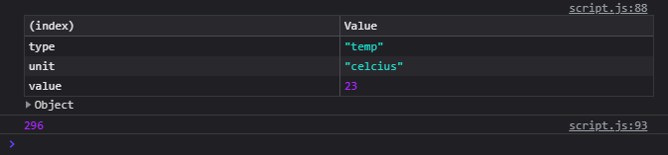
  + Debugger;
  + Placeholders – hold points in the execution of the code
* *//Coding challenge*
* *const* printForecast = *function*(*arr*){
* *let* forecast = "";
* for(*let* i = 0; i <= arr.length-1; i++){
* forecast = forecast + ` ${arr[i]}ºC in ${i+1} days...`;
* }
* return(forecast);
* }
* *const* data1 = [17, 21, 23];
* *const* data2 = [12, 5, -5, 0, 4];
* console.log(printForecast(data1));
* console.log(printForecast(data2));

Dom and Events Fundamentals

* Project #1 – Guess My Number
  + DOM – interfacing with html/CSS elements
    - What is DOM and DOM manipulation?
    - Document Object Model
      * The DOM tree structure
      * Document.QuerySelector()
      * The DOM !== Javascript
        + DOM are part of web APIs which are accessible through Javascript – libraries written in JS
* Selecting and manipulating elements
* document.querySelector('.message').textContent = 'Correct number!';
  + Note .message is a CSS ‘class selector’ and the overall JS structure to this line
    - Document. – dot notation as property accessor
    - querySelector – function
    - textContent – function
* Handling click events
* document.querySelector('.check').addEventListener('click', *function* (){
* console.log(document.querySelector('.guess').value);
* })
* Selecting CSS elements via Javascript
* document.querySelector('body').style.backgroundColor = '#60b307';
  + The value to be changed in the CSS code has to be contained in a string
  + These adjustments create in-line styles in the html file itself and leave the CSS untouched
  + Note the camel case notation of the CSS terminology ‘background-color’
* The DRY Principle – refractoring
* *const* displayMessage = *function*(*message*){
* document.querySelector('.message').textContent = message;
* }

*// document.querySelector('.message').textContent = guess > secretNumber ? '📈 Too high!' : '📉 Too low!';*

            displayMessage(guess > secretNumber ? '📈 Too high!' : '📉 Too low!');

* Refractoring via functioning out the document.querySelector and the use of ternary operators

The Modal Window

Working with classes

* Limitations of QuerySelector
  + Document.querySelectorAll
* Node list – unpacking the btnsOpenModel ‘array’
* *const* btnsOpenModal = document.querySelectorAll('.show-modal');
* for(*let* i = 0; i < btnsOpenModal.length; i++){
* btnsOpenModal[i].addEventListener('click', *function* (){
* console.log('Button clicked');
* });
* }
* 

Keyboard events

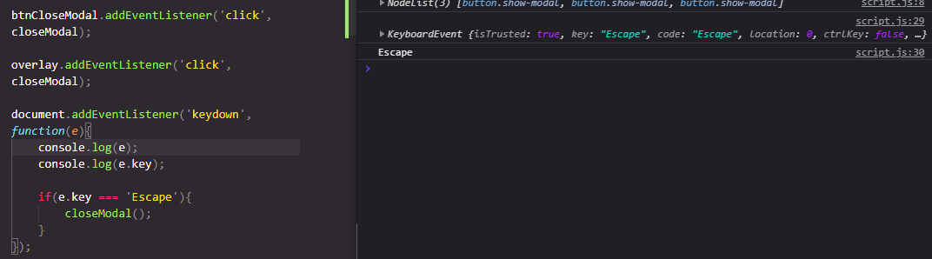

13 August 2021

Project 3 – Pig Game

* getElementById
* *const* score1 = document.getElementById('score--1');

19 August 2021

How Javascript works behind the scenes

* JS is a high level, object oriented, multi paradigm programming language.
  + High level – uses abstractions to shortcut
    - Low level – dealing with memory resource allocation etc etc
  + Garbage collected – removes memory of old data
  + Interpreted / just-in-time compiled – we write human written JS code that gets converted to machine code (0s and 1s)
  + Multi paradigm
    - What is a paradigm? An approach or programming mindset
    - Procedural
    - Object oriented (OOP)
    - Functional programming (FP)
  + Prototype based object oriented approach
    - Most in JS are objects except for primitive values (e.g numbers, strings etc) like arrays, objects
  + First class functions
    - Functions treated as regular variables – using functions within functions
  + Dynamically typed
    - No data type definitions – let x = 23; (*number)*
    - Automatic declaration of data type – x = “Jonas” (*string*)
  + Single threaded
    - Concurrency model – handling multiple tasks at the same time
    - JS runs on a single thread, one at a time
    - Non blocking event loop – an event loop takes long running tasks and executes them in the background, putting them into the main loop once complete
* Javascript engine and runtime
  + JS engine – a program that executes JS code
    - V8 engine – Google Chrome, nodeJS
  + What is in an engine?
    - A call stack – where code is executed through execution context
    - A heap – unstructured memory pool where objects are stored
  + How is code compiled to machine code?
    - Compilation vs interpretation
      * Compilation – entire code compiled to machine code at once, written to a binary file that can be executed by a computer
      * Source code – (compilation) – Portable file: Machine code – (execution, can happen way after compilation) – Program running
      * Interpretation – interpreter runs through the source code and executes it line by line
      * Modern JS uses a mix of compilation & interpretation for efficiency -> Just in time compilation
    - Just in time compilation
      * Code -> engine
        + Parse the code (read), into the Abstract Syntax Tree (AST)

Is the AST related to DOM? No.

* + - * + The AST then gets compiled into machine code -> Execution straight away
      * The execution stage happens in ‘optimisation strategies’ – executes an unoptimized version of machine code just to get some legs, then optimised and recompiled later down the track
  + Javascript runtime in the browser– container that includes all we need to run JS (like Google Chrome)
  + 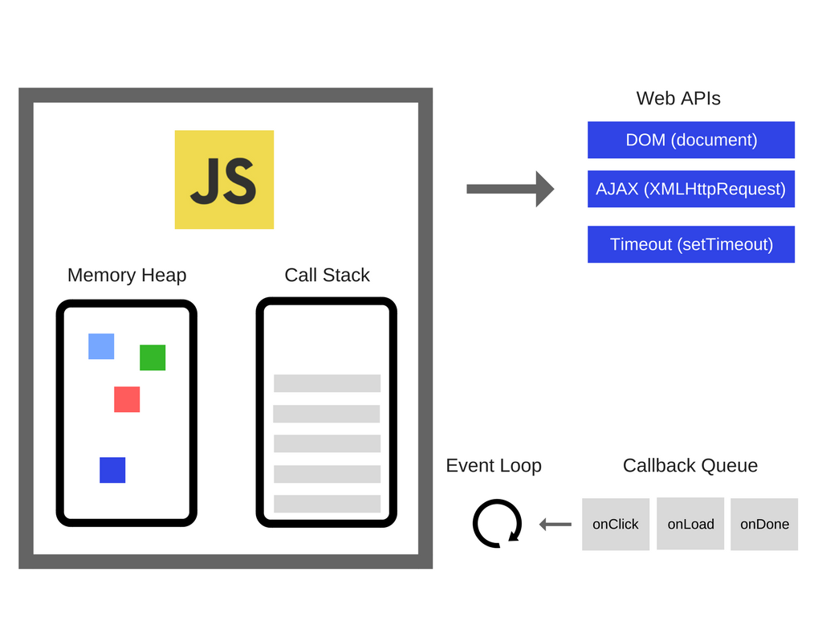
* Execution contexts and the call stack
  + Stages
    - Compilation
      * Creation of global execution context (only for top level code e.g variable declaration, function declaration, not the context within a function etc)
        + Execution of top level code inside global EC

Execution of functions and waiting for callbacks

* + Execution context (EC)– environment in which a piece of JS is executed, stores all the necessary information to allow the execution
    - What’s inside EC?
      * Variable environment – let, const, var declarations
        + Functions
        + Arguments objects
      * Scope chain – references to variables outside of the current function, stored within each function
      * *This* keyword
  + The call stack - a place where ECs get stacked on top of each other to keep track of where we are in the execution
* Scope and the scope chain
  + What is scoping? How program variables are accessed and organised. Where do variables live and can be accessed and where not?
  + Lexical scoping – scoping is controlled by placement of functions and blocks in the code
  + Scope – environment in which a certain variable is declared. Global scope, function scope, block scope
  + Scope of a variable – region of our code where a certain variable can be accessed
  + The three types of scope
    - Global – for top level code, for any code outside of any function or block, accessible everywhere
    - Function (local scope) – variables accessible only inside the function
    - Block – anything held within {}, variables only accessible within the block (ONLY for let, const; var can be accessible outside of the block)
      * Functions are also block scoped
  + Scope chain – child scopes can always access variables within parent scopes, looks up from bottom to top until the right variable is found, if not the code stops
  + 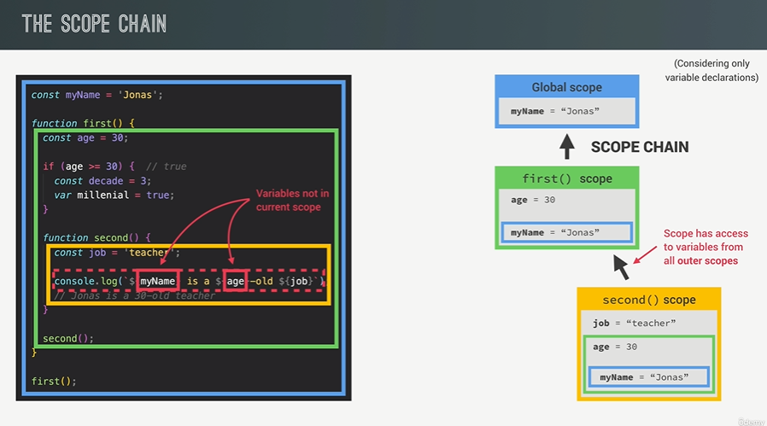
  + Note that the var ‘millenial’ variable is not block scoped but instead function scoped, in the first () function
  + 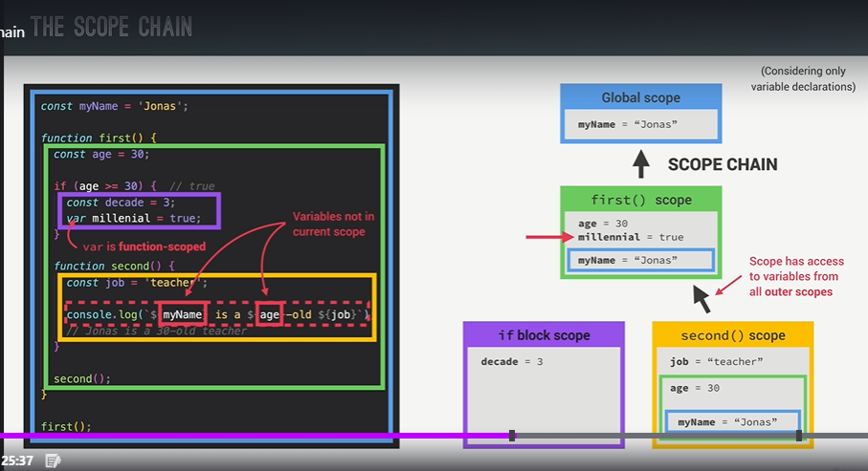
  + Note that the block scope cannot access the second() scope – scope chain can only operate up/down, not sideways. The block scope is on the same level as the function scope second()
  + Scope chain vs call stack – the call stack is the ‘up-to-down’ order in which global scope / function scope / block scopes are *called* in the code. The scope chain determines the parent/child relationship of the scope, the order in which functions are *written* in the code.
  + 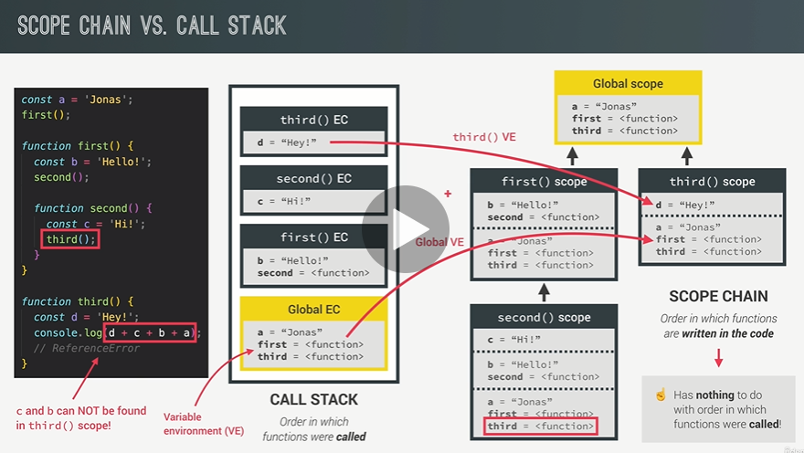
  + Scoping – where do variables live and where and where can’t we access them?
  + Three types of scope – global scope, scopes defined by functions, scopes defined by blocks
  + Only let and const are block scoped, var end up in the closest function scope
  + Lexical scoping – rules where we can access variables based on exactly where the function and block scopes are written
  + Every scope always has access to variables written from all its outer scopes – this is the scope chain
  + Variable lookup – when a variable is not in the current scope, it looks up towards the parent scopes until it finds what it is looking for. This is a one way street.
* Scoping in practice
* Hoisting in Javascript – makes some variables accessible before they are actually declared
  + ‘Let example;’ - ?
  + Behind the scenes – the code is scanned for variable declarations and a new property is created in the *variable environment object*
  + Functions – yes, initial value is set based on actual function
  + Var variables – yes, initial value is ‘undefined’
  + Let/const – no, initial value is ‘uninitialised’, Temporal Dead Zone
  + Function expressions / arrows – depends on whether using var, let/const
* Temporal Dead Zone – JS knows about the variable being present but does not allow its use until its initialisation
  + 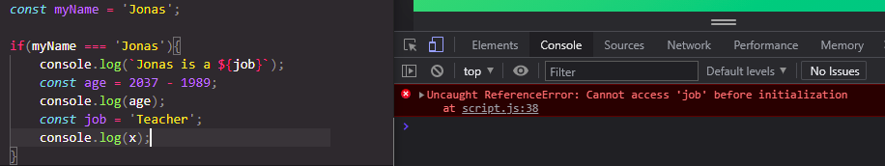
  + Why have a TDZ? Accessing variables before initialisation is bad practice and should be avoided & make const actually work (to be assigned at the beginning and left alone)
* Hoisting and TDZ in practice
  + 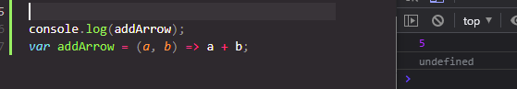
  + Var gets hoisted (allows for use before declaration) but is misleading bc initial value defaults to ‘undefined’
  + 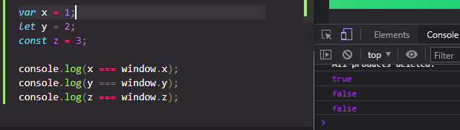

20 August 2021

The ‘this’ keyword

* This variable – One of the 3 ingredients for an execution context
  + Variable environment
  + Scope chain
  + This keyword
* This – special keyword created for every EC. Initial value points to the ‘owner’ of the function in which the *this* keyword is used
  + It is not static, and depends on how the function is called
* *const* jonas = {
* name: 'Jonas',
* year: 1989,
* calcAge: *function*() {
* return 2037 - *this*.year;
* }
* };
* jonas.calcAge();
  + Method – this takes on the object that is calling the method (the method being calcAge)
  + Simple function call – undefined
  + Arrow functions – this = <this of surrounding function (lexical this)>
  + Event listener – this = <DOM element that the handler is attached to>
* Simple function call example
* 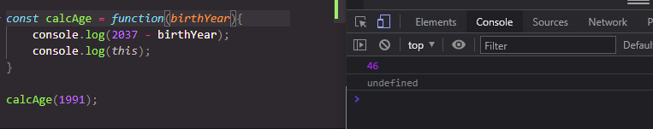
* Arrow function – grabs the *this* keyword of the parent function
* 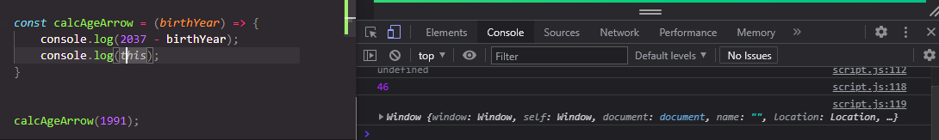
* Regular functions vs arrow functions
  + Arguments keyword can only exist in regular functions but not arrow. It is legal to have more arguments than what a function recognises:
* 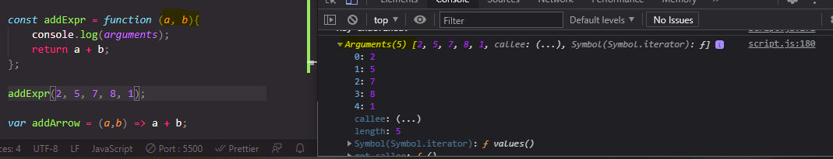
* Primitive vs Objects
  + Primitive data types
    - Number
    - String
    - Boolean
    - Undefined
    - Null
    - Symbol
    - BigInt
  + Objects
    - Object literal
    - Functions
    - Arrays
  + When talking about memory management - Primitive types & reference types
  + JS Engine – call stack & heap
    - Reference types – stored in heap
    - Primitive types – stored in call stack

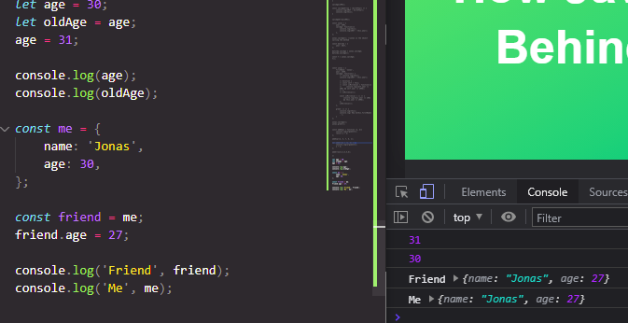

|  |  |  |
| --- | --- | --- |
| CALL STACK | | |
| Identifier | Address | Value |
| Age | 0001 | 30 |
| oldAge | 0002 | 31 |
| Me | 0003 | D30F |
| Friend |  |  |

|  |  |
| --- | --- |
| HEAP | |
| Address | Value |
| D30F | Name: ‘Jonas’, age: 30, |
|  |  |

* Note how ‘friend’ is assigned as a const but is not immutable the object property can change. This is because it is the reference value is changing, not the value at location 0003.
* Object.assign({}, <object to be copied> -> Shallow assignment

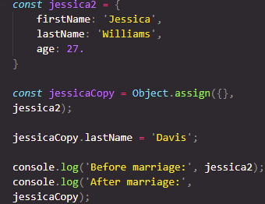

* Deep clone

21 August 2021

Data structures, modern operators and strings

Deconstructing arrays

* Unpacking and assigning the existing values in the array

*const* arr = [2, 3, 4];

*const* a = arr[1];

*const* b = arr[2];

*const* c = arr[3];

*const* [x, y, z] = arr;

* Reversing the order of an unpacked array
* *let* [main, , secondary] = restaurant.categories;
* [main, secondary] = [secondary, main];
* Nested destructuring

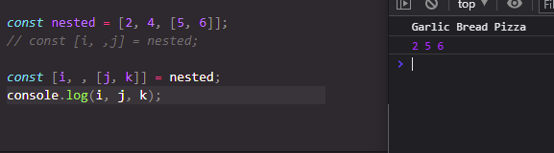

* Setting default values
* *//Default values*
* *const* [p = 1, q = 1, r = 1] = [8, 9];

Object destructuring

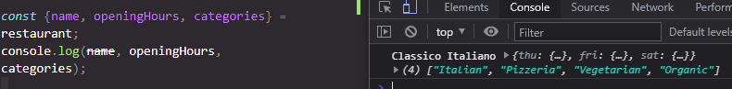

* What about unique variable names?

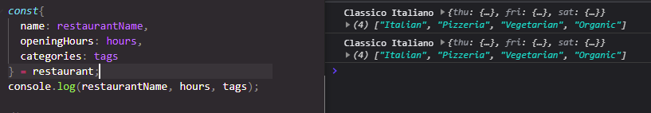

* Setting initial values as arrays

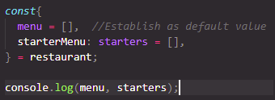

* Mutating variables within objects

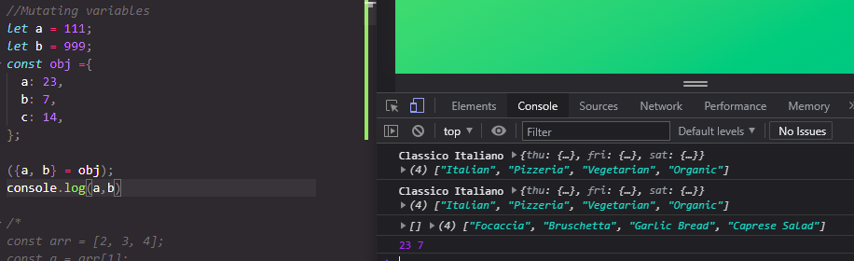

* Received information does not have to match order of function variables

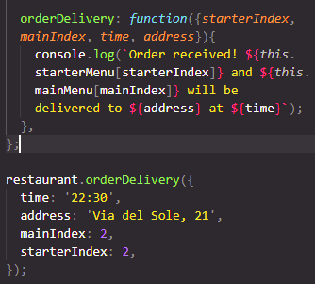

25 August 2021

The Spread Operator

* A more convenient way to add new values to existing arrays

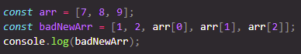

* Spread operator – grabs the values in the array (or more broadly any iterable) and writes them out individually

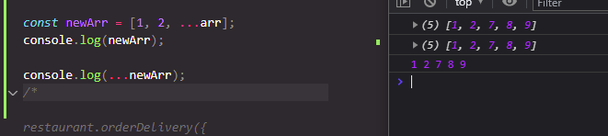

* Iterables – strings, arrays, maps and sets EXCEPT objects

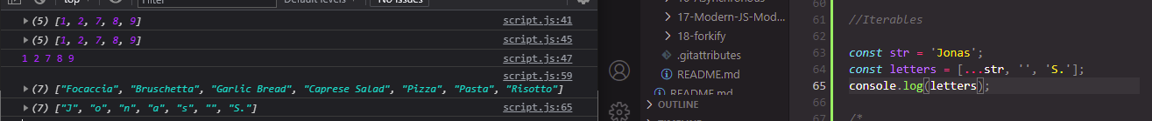

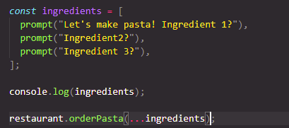

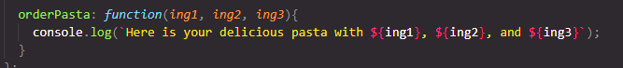

Rest pattern and parameters

* Rest pattern – does the opposite of spread, collects individual elements into an array

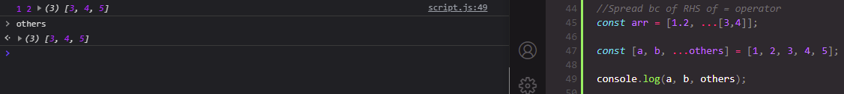

Short circuiting && and || (and & OR operators)

* Use any data type and return any data type



* Short circuiting – returns the very first truthy value
  + Returns ‘Hello’
* console.log(undefined || 0 || '' || 'Hello' || 23 || null);
* further examples
* *const* guests1 = restaurant.numGuests ? restaurant.numGuests : 10;
* console.log(guests1);
* *const* guests2 = restaurant.numGuests || 10;
* && - returns on the very first falsy value, if not, returns the last
* if (restaurant.orderPizza){
* restaurant.orderPizza('mushrooms', 'spinach');
* }
* *//Easy shortcut to if statement*
* restaurant.orderPizza && restaurant.orderPizza('mushrooms', 'spinach');

Nullish coalescing operator

restaurant.numGuests = 0;

*const* guests1 = restaurant.numGuests ? restaurant.numGuests : 10;

console.log(guests1);

* In this case, 10 is returned since restaurant.numGuests would be a falsy value
* The nullish coalescing operator overcomes this
* *const* guestCorrect = restaurant.numGuests ?? 10;
* console.log(guestCorrect);
* Nullish values – null and undefined are considered falsy , a 0 would be treated as truthy

Coding Challenge #1

*//Coding Challenge #1*

*const* game = {

  team1: 'Bayern Munich',

  team2: 'Borrussia Dortmund',

  players: [

  [

  'Neuer',

  'Pavard',

  'Martinez',

  'Alaba',

  'Davies',

  'Kimmich',

  'Goretzka',

  'Coman',

  'Muller',

  'Gnarby',

  'Lewandowski',

  ],

  [

  'Burki',

  'Schulz',

  'Hummels',

  'Akanji',

  'Hakimi',

  'Weigl',

  'Witsel',

  'Hazard',

  'Brandt',

  'Sancho',

  'Gotze',

  ],

  ],

  score: '4:0',

  scored: ['Lewandowski', 'Gnarby', 'Lewandowski',

  'Hummels'],

  date: 'Nov 9th, 2037',

  odds: {

  team1: 1.33,

  x: 3.25,

  team2: 6.5,

  },

  };

*const* players1 = game.players[0];

  console.log(players1);

*const* players2 = game.players[1];

  console.log(players2);

*const* [gk, ...fieldPlayers] = players1;

*const* allplayers = [...players1, ...players2];

  console.log(allplayers);

*const* players1Final = [...players1, 'Thiango', 'Coutinho', 'Perisic'];

*const* {

    team1: team1,

    x: draw,

    team2: team2,

  } = game.odds;

*const* printGoals = *function*(...*numberPlayers*){

*const* [...totalGoals] = [...numberPlayers];

    console.log(totalGoals);

    console.log(`${numberPlayers} at total goals of ${totalGoals[0].length}`);

  };

  printGoals(players1);

  printGoals(game.scored);

  team1 < team2 && console.log('Team 1 is more likely to win');

  team2 < team1 && console.log('Team 2 is more likely to win');

26 August 2021

Looping array – the for-of loop

*const* menu = [...restaurant.starterMenu,...restaurant.mainMenu];

for (*const* item1 of menu) console.log(item1);

for (*const* item1 of menu.entries()) console.log(item1);

Enhanced object literals

* Easier way to ‘literally’ write an object

Optional chaining – checking if objects/arrays are present

if (restaurant.openingHours && restaurant.openingHours.mon){

  console.log(restaurant.openingHours.mon.open);

};

*//WITH optional chaining*

console.log(restaurant.openingHours.mon?.open);

*//Methods*

console.log(restaurant.order?.(0, 1) ?? 'Method does not exist');

console.log(restaurant.orderRisotto?.(0, 1) ?? 'Method does not exist');

* Optional chaining & nullish coalescing operator often used hand in hand

Looping objects – object.keys, object.values, object.entries

* For-of loop & Object.keys
* for(*const* day of Object.keys(openingHours)){
* console.log(day);
* }

*//Property values*

*const* values = Object.values(openingHours);

console.log(values);

*const* entries = Object.entries(openingHours);

for(*const* [key, {open, close}] of entries){

  console.log(`On ${key} we are open at ${open} and closed at ${close}`);

};

3 September 2021

Sets

* What is a set? A collection of unique values
* *const* ordersSet = new Set([
* 'Pasta',
* 'Pizza',
* 'Pizza',
* 'Risotto',
* 'Pasta',
* 'Pizza',
* ]);
* console.log(ordersSet);
* console.log(ordersSet.size);
* .has, .size, .add operations, .clear, .delete, .values
* Cannot retrieve specific values from a set
* Sets are treated as iterables – can use for-of, while, if/or
* Making an array out of a set
* *const* staff = ['Waiter', 'Chef', 'Waiter', 'Manager', 'Chef', 'Waiter'];
* *const* staffUnique = [...new Set(staff)];
* console.log(staffUnique);

Maps

* Data structure that maps values to keys

*const* rest = new Map();

rest.set('name', 'Classico Italiano');

rest.set(1, 'Firenze, Italy');

rest.set(2, 'Lisbon, Portugal');

console.log(rest);

rest

  .set('categories', ['Italian', 'Pizzeria', 'Vegetarian', 'Organic'])

  .set('open', 11)

  .set('close', 23)

  .set(true, 'We are open')

  .set(false, 'We are closed');

  console.log(rest);

  console.log(rest.get('name'));

  console.log(rest.get(true));

  console.log(rest.get(1));

*const* time = 21;

  console.log(rest.get(time > rest.get('open') && time < rest.get('close')));

Maps – iteration

* Convert object to map
* *const* question = new Map([
* ['question', 'What is the best programming language in the world?'],
* [1, 'C'],
* [2, 'Java'],
* [3, 'JavaScript'],
* ['correct', 3],
* [true, 'Correct 👏'],
* [false, 'Try again!'],
* ]);
* console.log(question);
* console.log(Object.entries(openingHours));
* *const* hoursMap = new Map(Object.entries(openingHours));

console.log(question.get('question'));

for (*const* [key, value] of question) {

*// console.log(typeof (key));*

  if (typeof key === 'number') console.log(`Answer ${key} : ${value}`);

}

*const* answer = 3;

*// const answer = Number(prompt('Your answer'));*

console.log(answer);

console.log(question.get(question.get('correct') === answer));

*//Convert map to array*

console.log([...question]);

console.log(question.entries());

console.log(...question.keys());

console.log(...question.values());

Which data structure to use?

* Arrays / objects / sets / maps
* Sources of data?
  + From the program itself
  + From the user interface
  + From external sources
* Array / sets – simple list of values
* Objects / maps - Key / value pair
* Key differences
  + Arrays - Use when you need ordered data (and when retrieving / manipulating is important)
  + Sets – Use when you need to work on unique values (no duplicates), when high performance really matters
  + Objects – More traditional key/value stores, easier to write and access with . and []
  + Maps – better performance, keys can have any data type, easy to iterate, easy to compute size

4 September 2021

Working with strings

* Extracting individual elements within strings
* *const* airline = 'TAP Air Portugal';
* *const* plane = 'A320';
* console.log(plane[1]);
  + airline.length – 16 characters
* Methods – JS automatically converts the string in question to an object in order for methods to be applied
* console.log(airline.indexOf('r'));
* console.log(airline.lastIndexOf('r'));
* console.log(airline.indexOf('Portugal'));
  + .slice(start-index, end-index)





* Reverse extraction .slice (-X)
* Fixing capitalisation
* *const* passenger = 'jOnAS';
* *const* passengerLower = passenger.toLowerCase();
* *const* passengerCorrect = passengerLower[0].toUpperCase() + passengerLower.slice(1);
* console.log(passengerCorrect
* Check email - .trim email (removing whitespace)
* *const* email = 'hello@jonas.io';
* *const* loginEmail = '  Hello@Jonas.Io \n';
* *const* lowerEmail = loginEmail.toLowerCase();
* *const* trimmedEmail = lowerEmail.trim();
* console.log(trimmedEmail);
* *const* normalisedEmail = loginEmail.toLowerCase().trim();
* console.log(normalisedEmail);
* .replace(X,Y), .replaceAll(X, Y)
* *const* announcement = 'All passengers come to boarding door 23, boarding door 23!';
* console.log(announcement.replace('door', 'gate'). replace('door', 'gate'));
* *// console.log(announcement.replaceAll('door', 'gate'));*
  + Old school way – via regular expressions
* console.log(announcement.replace(/door/g, 'gate'));
* Booleans - .includes, .startsWith, .endsWith
* .split, .join – de-structuring and creating arrays from strings
* *const* [firstName, lastName] = 'Jonas Schmedtmann'.split(' ');

*const* newName = ['Mr', firstName, lastName.toUpperCase()].join(' ');

console.log(newName);

*const* capitaliseName = *function* (*name*) {

*const* nameArray = name.split(' ');

  console.log(nameArray);

*const* namesUpper = [];

  for(*const* word of nameArray){

    namesUpper.push(word[0].toUpperCase() + word.slice(1));

*// console.log(word[0]);*

  }

  console.log(namesUpper.join(' '));

};

capitaliseName('Jessica ann smith davis');

capitaliseName('julian goh');

* .padStart, .padEnd
* *const* maskCreditCard = *function*(*number*){
* *const* str = String(number);
* *const* strLength = str.length;
* console.log(str.slice(-4).padStart(strLength, 'X'));
* };
* Repeat
* *const* message2 = 'Bad weather... All departures delayed... ';
* console.log(message2.repeat(2));
* *const* planesInLine = *function* (*n*) {
* console.log(`There are ${n} planes in line ${'✈'.repeat(n)}`);
* };
* planesInLine(5);
  + Note that the plane repeat was needed to be encapsulated by ${} in order to use methods

Coding challenge

*//Coding Challenge #4*

document.body.append(document.createElement('textarea'));

document.body.append(document.createElement('button'));

document.querySelector('button').addEventListener('click',*function*(){

*const* text = document.querySelector('textarea').value;

  console.log(text);

*const* textArray = text.split('\n');

  console.log(textArray);

  console.log(textArray.entries());

  for(*const* [i, word] of textArray.entries()){

*const* lowerCase = word.toLowerCase().trim();

*const* afterUnderscore = lowerCase.slice(lowerCase.indexOf('_') + 1);

*const* beforeUnderscore = lowerCase.slice(0,(lowerCase.indexOf('_')));

*const* capitalise = afterUnderscore[0].toUpperCase() + afterUnderscore.slice(1);

*const* output = beforeUnderscore + capitalise;

    console.log(`${output.padEnd(20)}${'✅'.repeat(i + 1)}`);

  }

});

String Methods practice

*// Data needed for a later exercise*

*const* flights =

  '_Delayed_Departure;fao93766109;txl2133758440;11:25+_Arrival;bru0943384722;fao93766109;11:45+_Delayed_Arrival;hel7439299980;fao93766109;12:05+_Departure;fao93766109;lis2323639855;12:30';

*// 🔴 Delayed Departure from FAO to TXL (11h25)*

*//              Arrival from BRU to FAO (11h45)*

*//   🔴 Delayed Arrival from HEL to FAO (12h05)*

*//            Departure from FAO to LIS (12h30)*

*// const cutFlights = flights.replaceAll('+', '\n').replaceAll(';', ' ').replaceAll('_', ' ');*

for(*const* flight of flights.split('+')){

*// console.log(flight);*

*const* individualFlight = flight.split(';');

*// console.log(individualFlight);*

*const* descrip = individualFlight[0].replace('_', '').replace('_', ' ').replace('Delayed', '🛑 Delayed');

*// console.log(descrip);*

*const* from = individualFlight[1].slice(0,3).toUpperCase();

*// console.log(from);*

*const* to = individualFlight[2].slice(0, 3).toUpperCase();

*// console.log(to);*

*const* time = `(${individualFlight[3]})`;

*// console.log(time);*

  console.log(`${descrip} from ${from} to ${to} ${time}`.padStart(50));

};

5 September 2021

Closer look at functions – higher order method, bind, closure

Default values

*const* createBooking = *function* (*flightNum*, *numPassengers* = 1, *price* = 199) {

*//ES5*

*// numPassengers = numPassengers || 1;*

*// price = price || 199;*

*const* booking ={

        flightNum,

        numPassengers,

        price,

    }

    console.log(booking);

    bookings.push(booking);

};

createBooking('LH123');

createBooking('LH123', 2, 800);

* Leaving function input fields as ‘undefined’
* createBooking('LH123', undefined, 800);
* How passing arguments work – value vs reference
  + Passing a primitive type into an function – is creating a copy
  + Passing an object into a function – affects the original reference values
  + ** Javascript can only pass by values
* First class and higher order functions
  + Functions are treated as first class citizens, which means functions are simply values. Because functions are values, they can be stored in variables or properties.
  + Pass functions as arguments to other functions
  + Functions are another type of object – methods can be applied
  + Higher order functions:
    - A function that receives another function as an argument that then returns another function, or BOTH
      * The higher order function – addEventListener
      * Callback function - greet
* *const* btnClose = document.querySelector('.buy');
* btnClose.addEventListener('click', greet);
  + First class & higher order functions mean different things
* Functions accepting callback functions
* *const* oneWord = *function* (*str*) {
* return str.replace(/ /g, '').toLowerCase();
* };
* *const* upperFirstWord = *function* (*str*) {
* *const* [first, ...others] = str.split(' ');
* return [first.toUpperCase(), ...others].join(' ');
* };
* *// console.log(upperFirstWord('Apache Helicopter'));*
* *// const str = 'Apache Helicopter';*
* *// const[first, ...others] = str.split(' ');*
* *// console.log(first, ...others);*
* *//Higher order function*
* *const* transformer = *function* (*str*, *fn*) {
* console.log(`Original string: ${str}`);
* console.log(`Transformed string: ${fn(str)}`);
* console.log(`Transformed by: ${fn.name}`)
* };
* transformer('JavaScript is the best!', upperFirstWord);
  + .forEach(input-function)
* Why are callback functions important? To allow for abstraction (remove clutter, hide the minutiae)
  + Higher / lower levels of abstraction
* Functions returning functions
* *const* greet = *function*(*greeting*){
* return *function*(*name*){
* console.log(`${greeting} ${name}`);
* }
* }
* *const* greeterHey = greet('Hey');
* greeterHey('Jonas');

greet('Hello')('Jonas');

Converting to arrow:

*const* greet = *greeting* => *name* => console.log(`${greeting} ${name}`);

*const* greeterHey = greet('Hey');

greeterHey('Jonas')

* This keyword
* *const* lufthansa = {
* airline: 'Lufthansa',
* iataCode: 'LH',
* bookings: [],
* book: *function* (*flightNum*, *name*) {
* console.log(
* `${name} booked a seat on ${*this*.airline} flight ${*this*.iataCode}${flightNum}`
* );
* },
* };
* lufthansa.book(239, 'Jonas Schmedtmann');
* lufthansa.book(635, 'John Smith');
* Explicitly directing JS to know which ‘this’ it should be looking at - .call, .apply
* *const* eurowings = {
* airline: 'Eurowings',
* iataCode: 'EW',
* bookings: [],
* };
* *const* book = lufthansa.book;
* *// book(23, 'Sarah Williams');*
* book.call(eurowings, 23, 'Sarah Williams')

*//Apply method*

*const* flightData = [583, 'George Cooper'];

book.apply(swiss, flightData);

*//Call & spread - best practice*

book.call(swiss, ...flightData);

The bind method – allows permanent assignment of ‘this’ to a specific object

*const* bookEW = book.bind(eurowings);

bookEW(23, 'Steven Williams');

* Partial application
* *const* bookEW23 = book.bind(eurowings, 23);
* bookEW23('Jack Brown');

*/ With Event Listeners*

lufthansa.planes = 300;

lufthansa.buyPlane = *function* () {

  console.log(*this*);

*this*.planes++;

  console.log(*this*.planes);

};

*const* buyPlane = lufthansa.buyPlane.bind(lufthansa);

document.querySelector('.buy').addEventListener('click', lufthansa.buyPlane);

console.log(lufthansa);

*const* buyPlane = lufthansa.buyPlane.bind(lufthansa);

document.querySelector('.buy').addEventListener('click', buyPlane);

console.log(lufthansa);

Partial application – further example

*// Partial application*

*const* addTax = (*rate*, *value*) => value + value * rate;

console.log(addTax(0.1, 200));

*const* addVAT = addTax.bind(null, 0.23);

console.log(addVAT(100));

*//Alternative - callback*

*const* addTax1 = *function*(*rate*){

    return *function*(*value*){

        console.log(`${value + value * rate}`)

    }

}

*const* totalTax = addTax1(0.23);

totalTax(100);

Coding challenge

*const* poll = {

  question:

    'What is your favourite programming language?\n 0: JavaScript \n 1: Python \n 2: Rust \n 3: C++ \n (Write option number)',

  answers: [0, 0, 0, 0],

  registerNewAnswer: *function* () {

*const* option = Number(prompt(`${*this*.question}`));

*// this.array.push(option);*

    console.log(`Your answer is ${option}`);

    if (option === 0) {

*this*.answers[0] += 1;

    } else if (option === 1) {

*this*.answers[1] += 1;

    } else if (option === 2) {

*this*.answers[2] += 1;

    } else if (option === 3) {

*this*.answers[3] += 1;

    } else {

      console.log('Invalid input');

    }

*// console.log(this.answers);*

*this*.displayResults('string');

  },

  displayResults: *function* (*type*) {

    if (type === 'array') {

      console.log(*this*.answers);

    } else if (type === 'string') {

      console.log(`Poll results are ${*this*.answers.join(', ')}`);

    }

  },

};

document

  .querySelector('.poll')

  .addEventListener('click', poll.registerNewAnswer.bind(poll));

*const* bonus = {

*// answers: [5, 2, 3],*

  answers: [1, 5, 3, 9, 6, 1],

};

*const* bonusDisplay = poll.displayResults.bind(bonus);

bonusDisplay('string');

12 September 2021

Immediately Invoked Function Expressions (IIFE) – a function that disappears after it is called once

(*function*(){

  console.log('This will never run again');

});

(() => console.log('This will never run again'))();

* Reminder of global / local scopes – global cannot access local variables but local variables can access higher scope variables

Closures – bringing together Execution Contexts, Call Stack and Scope Chain

*const* secureBooking = *function* () {

*let* passengerCount = 0;

  return *function*(){

    passengerCount++;

    console.log(`${passengerCount}`);

  }

};

*const* booker = secureBooking();

Call stack

* Global execution context – secureBooking = <f>
  + secureBooking() Execution Context created, a variable environment that contains all its variables
* Global scope – secureBooking = <f>

Strange how the local environment can be kept updated each time the booker function gets called – after all, the local variable gets defined each function call (?)

* Closure – lets the function remember all the variables at their birthplaces e.g passengerCount within the secureBooking function
  + A function has access to the variable environment of the execution context in which it was created, even after the EC is removed from the call stack
* Formal definition - A closure is the closed-over variable environment of the execution context in which a function was created, even after that execution context is gone
  + OR – A closure gives a function access to all its variables of its parent function even after that parent function has returned. The function keeps a reference to its outer scope which preserves the scope chain through time
* Closures happen automatically, are not a tangible JavaScript object
* Console.dir(booker)

* Another example
* *let* f;
* *const* g = *function*(){
* *const* a = 23;
* f = *function*(){
* console.log(a * 2);
* }
* }
* g();
* f();
* What if f gets re-assigned?
* *const* h = *function*(){
* *const* b = 777;
* f = *function*(){
* console.log(b * 2);
* }
* }
* g();
* f();
* h();
* f();

Working with Arrays

* Array Methods – methods are simply functions we can call on objects, arrays themselves are therefore considered as objects
* *let* arr = ['a', 'b', 'c', 'd', 'e'];
* console.log(arr.slice(2));
* console.log(arr.slice(2, 4));

*//Creating shallow copies*

console.log(arr.slice());

console.log([...arr]);

Splice method – similar function to slice but permanently mutates the original variable

Reverse method – reverses the order of the array, mutates original variable

*const* letters = arr.concat(arr2);

console.log(letters);

console.log([...arr, ...arr2]);

forEach method

for(*const* movement of movements){

  if(movement > 0){

    console.log(`You deposited ${movement}`);

    } else {

      console.log(`You withdrew ${Math.abs(movement)}`);

    }

}

movements.forEach(*function*(*movement*){

  if(movement > 0){

    console.log(`You deposited ${movement}`);

    } else {

      console.log(`You withdrew ${Math.abs(movement)}`);

    }

})

* Note that .forEach automatically accepts index / array as entries
* for(*const* [i, movement] of movements.entries()){
* if(movement > 0){
* console.log(`Movement ${i + 1}: You deposited ${movement}`);
* } else {
* console.log(`Movement ${i + 1}: You withdrew ${Math.abs(movement)}`);
* }
* }
* *//Equivalent process - through forEach (higher order) function*
* movements.forEach(*function*(*movement*, *index*, *array*){
* if(movement > 0){
* console.log(`Movement ${index + 1}: You deposited ${movement}`);
* } else {
* console.log(`Movement ${index + 1}: You withdrew ${Math.abs(movement)}`);
* }
* });

** Refresh - .entries method – breaks down an array into its index & value

forEach with Maps and Sets

*const* currencies = new Map([

  ['USD', 'United States dollar'],

  ['EUR', 'Euro'],

  ['GBP', 'Pound sterling'],

]);

currencies.forEach(*function*(*value*, *key*, *map*){

  console.log(`${key}: ${value}`);

});

Bankist application

Creating DOM elements

* .insertAdjacentHTML
* .innerHTML – similar function to textContent

Array methods - data transformations of map, filter, reduce

* Map – similar to for/each, creates a brand new array from the previous data
  + Returns a new array containing the results of applying an operation on all original array elements
* Filter – returns a new array containing the array elements that pass a specified test condition
* Reduce – reduces all array elements down to a single value

The Map method

*const* movements = [200, 450, -400, 3000, -650, -130, 70, 1300];

*const* eurToUSD = 1.1;

*const* movementsUSD = movements.map(*function*(*mov*){

  return mov * eurToUSD;

});

console.log(movements);

console.log(movementsUSD);

* Using the arrow function for cleaner (but less readable) code

*const* show = movements.map(*function*(*movement*, *i*, *arr*){

  if(movement > 0){

    console.log(`Movement ${i + 1}: You deposited ${movement}`);

    } else {

      console.log(`Movement ${i + 1}: You withdrew ${Math.abs(movement)}`);

    }

});

*const* show1 = movements.map((*movement*, *i*, *arr*) => {

  if(movement > 0){

    console.log(`Movement ${i + 1}: You deposited ${movement}`);

    } else {

      console.log(`Movement ${i + 1}: You withdrew ${Math.abs(movement)}`);

    }

});

*const* movementDescriptions = movements.map(

  (*movement*, *i*) =>

    `Movement ${i + 1}: You ${movement > 0 ? 'deposited': 'withdrew'} ${Math.abs(movement)}`

  );

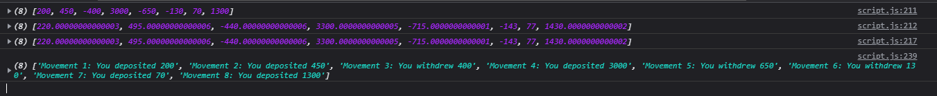

Creating usernames

*const* createUsernames = *function*(*accs*){

  accs.forEach(*function*(*account*){

    account.username = account.owner.toLowerCase()

    .split(' ')

    .map(*name* => name[0])

    .join('');

  });

}

createUsernames(accounts);

console.log(accounts);

13 September 2021

The Filter method

*const* deposits = movements.filter(*function*(*mov*){

  return mov > 0;

});

console.log(movements);

console.log(deposits);

* How does this compare to the original for/of loop?

*const* depositsFor = [];

for(*const* mov of movements){

  if (mov > 0) depositsFor.push(mov);

};

console.log(depositsFor);

The Reduce method

*const* sum = movements.reduce(*function*(*acc*, *cur*, *i*, *arr*){

  return acc + cur;

}, 0);

console.log(sum);

* Note how the initiating variables of the function are very different - accumulator
* 0 initial value

* For/each comparison
* *let* balance2 = 0;
* for(*const* mov of movements) balance2 += mov;
* console.log(balance2);

Coding challenge

*//Coding challenge #2*

*const* data1 = [5, 2, 4, 1, 15, 8, 3];

*const* data2 = [16, 6, 10, 5, 6, 1, 4];

*const* calcAverageHumanAge = *function*(*ages*){

*const* convertAge = ages.map(*function*(*dogAge*){

    if(dogAge <= 2){

      return 2 * dogAge;

    } else {

      return 16 + dogAge * 4;

    }

  });

  console.log(convertAge);

*const* convertAgeFiltered =  convertAge.filter(*function*(*age*){

    return age > 18;

  });

  console.log(convertAgeFiltered);

*// const convertAgeAve = convertAgeFiltered.reduce(function(acc, curr){*

*//   return acc + curr;*

*// }, 0) / convertAgeFiltered.length;*

*const* convertAgeAve = convertAgeFiltered.reduce(*function*(*acc*, *curr*, *i*, *arr*){

    return acc + curr / arr.length;

  }, 0);

  console.log(convertAgeAve);

};

calcAverageHumanAge(data1);

calcAverageHumanAge(data2);

The magic of chaining methods – filter, map, reduce

*onst* movements = [200, 450, -400, 3000, -650, -130, 70, 1300];

*const* eurToUSD = 1.1;

*const* totalDepositsUSD = movements

  .filter(*mov* => mov > 0)

  .map(*mov* => mov * eurToUSD)

  .reduce((*acc*, *mov*) => acc + mov, 0);

console.log(totalDepositsUSD);

* Good practice of how to debug a codeblock with stacked methods – using the parameters of the callback functions
* *const* totalDepositsUSD = movements
* *// .filter(mov => mov > 0)*
* *// .map(mov => mov * eurToUSD)*
* *// .reduce((acc, mov) => acc + mov, 0);*
* .filter((*mov*, *i*, *arr*) => {
* console.log(arr);
* return mov > 0;
* })
* .map((*mov*, *i*, *arr1*) => {
* console.log(arr1);
* return mov * eurToUSD
* })
* .reduce((*acc*, *mov*) => acc + mov, 0);
* console.log(totalDepositsUSD);
* Bad practice to chain methods that permanently mutates the original data

Coding challenge #3 – chaining practice

*const* calcAverageHumanAge1 = *ages* => {

*const* convertAge = ages

    .map(*function* (*dogAge*) {

      if (dogAge <= 2) {

        return 2 * dogAge;

      } else {

        return 16 + dogAge * 4;

      }

    })

    .filter(*function* (*age*) {

      return age > 18;

    })

    .reduce(*function* (*acc*, *curr*, *i*, *arr*) {

      return acc + curr / arr.length;

    }, 0);

    console.log(convertAge);

};

The Find Method – returns the first element in an array that matches the condition, does not return an array like the filter method

*// Find method*

*const* movements = [200, 450, -400, 3000, -650, -130, 70, 1300];

*const* firstWithdrawal = movements.find(*mov* => mov < 0);

* Searching for a user out of an array of accounts

*const* account = accounts.find(*acc* => acc.owner === 'Jessica Davis');

console.log(account);

Creating user login functionality

btnLogin.addEventListener('click',*function*(*e*){

*//Prevent form from submitting*

  e.preventDefault();

  console.log('LOGIN');

})

Check if user details exist

if (currentAccount?.pin === Number(inputLoginPin.value)){

    console.log('LOGIN');

  }

.blur – remove cursor from login

*//Clear login fields*

  inputLoginUsername.value = inputLoginPin.value = '';

  inputLoginPin.blur();

5 October 2021

Implementing Transfers

findIndex method – account deletion

*const* index = accounts.findIndex(

*acc* => acc.username === currentAccount.username

    );

    accounts.splice(index, 1);

some and every

- .includes (to check for specific value in array)

- Some – Boolean check

*const* anyDeposits = account1.movements.some(*mov* => mov > 150);

- Every - if every element passes the test in the callback function, only then it returns true

** Check if only deposits

*// Every method*

console.log(account1.movements.every(*mov* => mov > 0));

Flat and flatmap methods

- .flat() - Unpacks nested arrays into a single full array, but is limited to surface layer only



*const* arrDeep = [[[1,2],3], [4,[5,6]], 7, 8];

console.log(arrDeep.flat(2));

Calculating total value of all movements across all the accounts

*const* accountMovements = accounts.map(*acc* => acc.movements);

console.log(accountMovements);

*const* allMovements = accountMovements.flat();

console.log(allMovements);

*//JG method lol*

*let* bankTotal = 0;

for(*const* mov of accountMovements.flat()){

  bankTotal = bankTotal + mov;

}

console.log(bankTotal);

*//JS method*

*const* overallBalance = allMovements.reduce((*acc*,*mov*) => acc + mov)

console.log(overallBalance);

- flatMap – DRY principle of dealing with nested arrays

*const* overallBalance = accounts

  .map(*acc* => acc.movements)

  .flat()

  .reduce((*acc*, *mov*) => acc + mov, 0);

console.log(overallBalance);

*//Flat map*

*const* overallBalance2 = accounts

  .flatMap(*acc* => acc.movements)

  .reduce((*acc*, *mov*) => acc + mov, 0);

console.log(overallBalance2);

Sorting Arrays

.sort() – works well for strings but not numbers

*const* owners = ['Jonas', 'Zach', 'Adam', 'Martha'];

console.log(owners.sort());

accounts1.sort((*a*, *b*) => {

  if (a > b) return 1;

  if (b > a) return -1;

});

Even DRYier

console.log(account1.movements.sort((*a*,*b*) => a - b));

More ways of creating and filling arrays

- new Array()



.fill method

- .fill(value, start-index, end-index)





Array.from() method

*const* z = Array.from({length: 7}, (*cur*, *i*) => i + 1);



Which array method to use?

|  |  |  |  |  |
| --- | --- | --- | --- | --- |
| To mutate original array | A new array | An array index | Know if array includes | To transform to value |
| To add to original:   * .push * .unshift   Remove from original   * .pop * .shift * .splice   Others:   * .reverse * .sort * .fill | Compute from original:   * .map   Filtered using condition   * .filter   Portion of original   * .splice   Add original to other   * .concat   Flattening the original   * .flat * .flatMap | Based on value   * .indexOf   Based on test condition   * .findIndex | Based on value   * .includes   Based on test condition   * .some * .every | Based on accumulator   * .reduce |
| An array element  Based on test condition   * .find | A new string  Based on separator string:   * .join | To just loop array  Based on callback (do some work but not produce anything new)   * .forEach |

6 October 2021

* ++ operator
  + ++count vs count++
* Making a new object from .reduce method
* *//*
* *const* { deposits, withdrawals } = accounts
* .flatMap(*acc* => acc.movements)
* .reduce(
* (*sums*, *curr*) => {
* *// curr > 0 ? (sums.deposits += curr) : (sums.withdrawals += curr);*
* sums[curr > 0 ? 'deposits' : 'withdrawals'] += curr;
* return sums;
* },
* { deposits: 0, withdrawals: 0 }
* );
* console.log(deposits, withdrawals);

*// 4. this is a nice title > This Is a Nice Title*

*const* convertTitleCase = *function* (*title*) {

*const* exceptions = ['a', 'an', 'the', 'but', 'or', 'on', 'in', 'with'];

*const* titleCase = title

    .toLowerCase()

    .split(' ')

    .map(*word* =>

      exceptions.includes(word) ? word : word[0].toUpperCase() + word.slice(1)

    );

  return titleCase;

};

console.log(convertTitleCase('this is a nice title'));

7 October 2021

Converting and checking numbers

* Numbers are stored in JS behind the scenes as integers
* Base 10 vs binary base 2
  + 0 to 9
  + 0s and 1s
  + Avoid really scientific calculations in Javascript
* String to numbers conversion
  + Number()
  + Type coercion
    - Console.log(+’23’);
* Parsing – Number.parseInt (‘ ‘, 10 or 2), Number.parseFloat

* ParseFloat – best way to grab numbers from strings
* isNan
* isFinite – best way to check if a value is a number
* console.log(Number.isFinite(23 / 0));

Other mathematical operations

* Squareroot, exponentiation, pi, min/max
* console.log(Math.sqrt(25));
* console.log(25 ** (1/2));
* console.log(Math.max(5, 18, '23', 11, 2));
* console.log(Math.max(5, 18, '23px', 11, 2));
* console.log(Math.min(5, 18, '23', 11, 2));
* console.log(Math.PI * Number.parseFloat('10px') ** 2);
* Random number generator within set range
* *//Random dice roll and random number generator*
* console.log(Math.trunc(Math.random() * 6) + 1);
* *const* randomInt = (*min*, *max*) => Math.trunc(Math.random() * (max - min) + 1) + min;
* *// 0 ... 1 -> 0 ... (max - min) -> min ... max*
* Rounding integers
  + Math.round
  + Math.trunc
  + Math.floor
  + Math.ceil
* Math.trunc vs Math.floor
  + Floor is applicable to -ve numbers as well
* Rounding decimals – toFixed, can do type coercion
* console.log((2.7).toFixed(3));



Note that the output is a string, to overcome this add the + sign (easy shortcut to Number() )

console.log(+(2.345).toFixed(2));

8 October 2021

The Remainder operator

console.log(5 % 2);

* Useful for checking even or odd numbers
  + 8 % 2 = 0
  + 9 % 2 = 1

labelBalance.addEventListener('click', *function*(){

[...document.querySelectorAll('.movements__row')].forEach(*function*(*row*,*i*){

*// 0, 2, 4, 6*

  if(i % 2 === 0) row.style.backgroundColor = 'orangered';

*// 0, 3, 6, 9*

  if(i % 3 === 0) row.style.backgroundColor = 'blue';

});

});

bigInt

* Maximum JS limitation in representing integers
* console.log(2 ** 53 - 1);
* console.log(Number.MAX_SAFE_INTEGER);
* What if we have to deal with numbers bigger than this? This is where bigInt comes in
* console.log(100213123123210*n* * 100000*n*);

*//Convert regular numbers to bigint*

console.log(2312931239812*n* + BigInt(23));

* Logical operators are exceptions – can mix bigint with normal integers
* console.log(20*n* > 15); // True
* console.log(20*n* == '20'); // True, loose equality operator coercion
* String concatenations – converts bigint to string

console.log(123123123123*n* + 'is REALLY BIG!');

Creating dates

* The four ways
  + New Date()
* *const* now = new Date();
* console.log(now);

console.log(new Date(2037, 10, 19, 15, 23, 5));

Thu Nov 19 2037 15:23:05 GMT+1000 (Australian Eastern Standard Time)

**Note that Javascript works the month in zero-based

console.log(new Date(0));

console.log(new Date(3 * 24 * 60 * 60 * 1000));

Sun Jan 04 1970 10:00:00 GMT+1000 (Australian Eastern Standard Time)

* .getFullYear() method – do not use .getYear **
* .getMonth() method
* .getDate();
* .getDay();
* .getHours();
* .getMinutes();
* .getSeconds();
* .toISOString();
* .getTime() – time stamp, ms since Jan 1 1970
* Date.now(); - shortcut to get current timestamp
* *const* newISO = new Date(future.getTime());
* console.log(newISO.toISOString());
* .setFullYear()… month.. minutes etc

Formatting dates with .padStart

*//Create current date and time*

*const* now = new Date();

*const* day = `${now.getDate()}`.padStart(2, 0);

*const* month = `${now.getMonth() + 1}`.padStart(2, 0);

*const* year = now.getFullYear();

*const* hour = `${now.getHours()}`.padStart(2, 0);

*const* min = `${now.getMinutes()}`.padStart(2, 0);

    labelDate.textContent = `${day}/${month}/${year}, ${hour}:${min}`

Operations with dates

*const* formatMovementDate = *function* (*date*){

*const* calcDaysPassed = (*date1*, *date2*) => Math.round(Math.abs(date2 - date1) / (1000 * 60 * 60 * 24));

*const* daysPassed = calcDaysPassed(date, new Date());

  console.log(daysPassed);

  if(daysPassed === 0) return 'Today';

  if(daysPassed === 1) return 'Yesterday';

  if(daysPassed <= 7) return `${daysPassed} days ago`;

  else{}

*const* day = `${date.getDate()}`.padStart(2, '0');

*const* month = date.getMonth() + 1;

*const* year = date.getFullYear();

  return `${day}/${month}/${year}`;

}

Internationalising dates – formatting dates/times across different languages/countries

*const* now = new Date();

*const* options ={

  day: 'numeric',

  month: 'long',

  year: 'numeric',

  hour: 'numeric',

  minute: 'numeric',

  weekday: 'long',

}

*const* locale = navigator.language;

labelDate.textContent = new Intl.DateTimeFormat(locale, options).format(now);  *//Google 'ISO language code table'*

Dates – ‘today’, ‘yesterday’ etc

*const* formatMovementDate = *function* (*date*, *locale*) {

*const* calcDaysPassed = (*date1*, *date2*) =>

    Math.round(Math.abs(date2 - date1) / (1000 * 60 * 60 * 24));

*const* daysPassed = calcDaysPassed(date, new Date());

*// console.log(daysPassed);*

  if (daysPassed === 0) return 'Today';

  if (daysPassed === 1) return 'Yesterday';

  if (daysPassed <= 7) return `${daysPassed} days ago`;

  else {

  }

*// const day = `${date.getDate()}`.padStart(2, '0');*

*// const month = date.getMonth() + 1;*

*// const year = date.getFullYear();*

*// return `${day}/${month}/${year}`;*

  return new Intl.DateTimeFormat(locale).format(date);

};

Internationalising numbers

*const* num = 23237.23;

*const* options = {

  style: "unit",

  unit: 'mile-per-hour',

}

console.log('US:    ', new Intl.NumberFormat('en-US', options).format(num));

console.log('Germany:    ', new Intl.NumberFormat('de-DE', options).format(num));

Timers: setTimeout and setInterval

setTimeout((*ing1*, *ing2*) => console.log(`Here is your pizza 🍕 with ${ing1} and ${ing2}`), 3000, 'olives', 'spinach');

Here is your pizza 🍕 with olives and spinach

*const* ingredients = ['olives', 'spinach'];

*const* pizzaTimer = setTimeout((*ing1*, *ing2*) => {console.log(`Here is your pizza 🍕 with ${ing1} and ${ing2}`); console.log(...ingredients)} , 3000, ...ingredients);

if(ingredients.includes('chicken')) clearTimeout(pizzaTimer);

Implementing a countdown timer

*const* startLogOutTimer = *function* () {

*const* tick = *function* () {

*const* min = String(Math.trunc(time / 60)).padStart(2, 0);

*const* sec = String(time % 60).padStart(2, 0);

*// In each call, print remaining time to UI*

    labelTimer.textContent = `${min}:${sec}`;

*//When 0 seconds, stop timer and log out user*

    if (time === 0) {

      clearInterval(timer);

      labelWelcome.textContent = 'Log in to get started';

      containerApp.style.opacity = 0;

      currentAccount = {};

    }

*// Decrease 1s*

    time--;

  };

*// Set time to 5 minutes*

*let* time = 120;

*// Call the timer every second*

  tick();

*const* timer = setInterval(tick, 1000);

  return timer;

};

14 October 2021

Bankist landing page

What is the DOM? Review

* Allow JS to interact with browser
  + Create, modify and delete HTML elements
  + Set styles, classes and attributes
  + Listen and respond to events
* DOM tree is generated from HTML document which we can then interact with
* DOM is a very complex API that contains lots of methods and properties to interact with the DOM tree “document.addEventListener()”
* DOM API behind the scenes – all DOM elements are represented by “node” type
  + Node type – that have access to methods (.textContext, .childNodes, .parentNode) represented by JS object
    - Element type - **<p>** Paragraph **</p>**
      * HTMLElement
        + HTMLButtonElement
        + HTMLDivElement
    - Text type - <p> **Paragraph** </p>
    - Comment type - <!—**Comment** --!>
    - Document type
      * .querySelector()
      * .createElement()
      * .getElementbyId()
  + Inheritance – all child types will inherit all the properties of its parent types but the inverse does not work
    - A HTMLElement is also an Element and a Node
  + Why does addEventListener work on all DOM elements?
    - Event Target - Because it sits above the Node type in the inheritance, parent of the Node and Window node type

Selecting, creating and deleting elements

* Document., querySelector, querySelectorAll, getElementbyId, getElementsByTagName, getElementsbyClassName
  + Outputs – NodeList (static) vs HTMLCollection (live)
* console.log(document.documentElement);
* console.log(document.head);
* console.log(document.body);
* document.querySelector('.head');
* *const* allSections = document.querySelectorAll('.section');
* console.log(allSections); *// This forms a NodeList*
* document.getElementById('section--1');
* *const* allButtons = document.getElementsByTagName('button');
* console.log(allButtons); *//Note that this produces a HTMLCollection - this is a live collection, will reflect any changes that occur in the HTML*
* console.log(document.getElementsByClassName('btn'))
* Using both .prepend and .append simultaneously requires .cloneNode(true)
* header.prepend(message);
* *// header.append(message);*
* header.append(message.cloneNode(true));
* . before and .after
* .remove()
* *// Delete elements*
* document.querySelector('.btn--close-cookie').addEventListener('click', *function*(){
* message.remove();
* *// message.parentElement.removeChild(message);*
* });

Styles, attributes and classes

* Inline styles - .style
* message.style.backgroundColor = '#37383d';
* message.style.width = '120%';
* .getComputedStyle
* console.log(getComputedStyle(message).color);
* Editing directly the height of html element
* message.style.height = Number.parseFloat(getComputedStyle(message).height,10) + 40 + 'px';
* */ Editing custom properties*

document.documentElement.style.setProperty('--color-primary', 'orangered');

Attributes

*// Attributes*

*const* logo = document.querySelector('.nav__logo');

console.log(logo.src);

console.log(logo.alt);

console.log(logo.className);

* Custom attributes
  + Reading
* console.log(logo.getAttribute('designer'));
* logo.setAttribute('company', 'Bankist');
* Note .getAttribute on src
* console.log(logo.src);
* console.log(logo.getAttribute('src')); *// Relative, local location*
* Data attributes – accessing custom names with .dataset
* *//Data attributes*
* console.log(logo.dataset.versionNumber);

<img

*src*="img/logo.png"

*alt*="Bankist logo"

*class*="nav__logo"

*id*="logo"

*designer* = "Jonas"

*data-version-number*="3.0"

        />

* Classes
* *// Classes*
* logo.classList.add('c');
* logo.classList.remove('c');
* logo.classList.toggle('c');
* logo.classList.contains('c');

Smooth scrolling

Determine initial coordinates

.getBoundingClientRect()

console.log('Current scroll (X/Y)', window.pageXOffset, window.pageYOffset);

  console.log('Height/width viewport', document.documentElement.clientHeight, document.documentElement.clientWidth)

Incomplete scroll – does not work if current scroll location is not at top of page

*//Scrolling*

  window.scrollTo(s1coords.left, s1coords.top);

window.scrollTo(

    s1coords.left + window.pageXOffset,

    s1coords.top + window.pageYOffset

  );

Most modern:

window.scrollTo({

    left: s1coords.left + window.pageXOffset,

    top: s1coords.top + window.pageYOffset,

    behaviour: 'smooth',

  });

  section1.scrollIntoView({behavior: 'smooth'});

Events and event handler

* An event is a signal generated by a certain DOM node after an action is taken
* addEventListener vs .onmouseenter
* *const* h1 = document.querySelector('h1');
* h1.addEventListener('mouseenter', *function*(*e*){
* alert('addEventListener: great! You are reading the heading')
* });
* h1.onmouseenter = *function*(*e*){
* alert('addEventListener: great! You are reading the heading')
* };
* .removeEventListener()
  + setTimeout(function)

15 October 2021

Event propagation – bubbling and capturing

* Capturing phase -> Target phase -> Bubbling phase

* An event travels down through the parent elements to reach its target and then bubbles back up through all the parents again back to the document
* *const* randomInt = (*min*, *max*) => Math.floor(Math.random() * (max-min+1) + min);
* *const* randomColor = () => `rgb(${randomInt (0,255)}, ${randomInt (0,255)}, ${randomInt (0,255)})`;
* console.log(randomColor());
* document.querySelector('.nav__link').addEventListener('click', *function*(*e*){
* *this*.style.backgroundColor = randomColor();
* })
* document.querySelector('.nav__links').addEventListener('click', *function*(*e*){
* *this*.style.backgroundColor = randomColor();
* })
* document.querySelector('.nav').addEventListener('click', *function*(*e*){
* })

* .nav__link -> the event listener triggers a background colour change for both the child and parent, as the event bubbles up. Cliking on .nav__links parent only does not affect the child
* E.target and e.currentTarget
  + currentTarget – element that the event handler is attached
  + Target – where the event originally happened

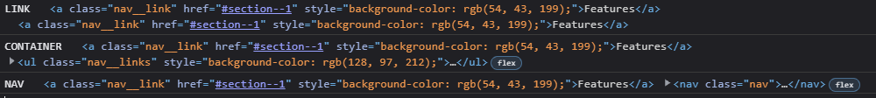

* E.stopPropogation() – to stop bubbling, but generally not good practice
* *// Stop propogation*
* e.stopPropagation();
* Listening to event during Capturing Phase vs Bubbling Phase – but Capturing rarely used in modern JS
* document.querySelector('.nav').addEventListener('click', *function*(*e*){
* *this*.style.backgroundColor = randomColor();
* console.log('NAV', e.target, e.currentTarget);
* }, true)

Event delegation – implementing page delegation

Smooth scroll navigation

*// Navigation*

btnScrollTo.addEventListener('click', *function* (*e*) {

  section1.scrollIntoView({ behavior: 'smooth' });

});

document.querySelectorAll('.nav__link').forEach(*el* => el.addEventListener('click', *function*(*e*){

  e.preventDefault();

  console.log('LINK');

*const* id = *this*.getAttribute('href');

  console.log(id);

  document.querySelector(id).scrollIntoView({behavior: 'smooth'});

}))

Implementing event delegation – delegating the eventListener to the parent element as opposed to individually to all 3 child elements

document.querySelector('.nav__links').addEventListener('click', *function*(*e*){

  console.log(e.target);

    e.preventDefault();

  if(e.target.classList.contains('nav__link')){

    console.log('LINK');

*const* id = e.target.getAttribute('href');

    console.log(id);

    document.querySelector(id).scrollIntoView({behavior: 'smooth'});

  }

})

DOM traversing

Downwards

* .childNodes
* .children
* .firstElementChild
* .lastElementChild

Upwards

* .parentNode
* .parentElement
* .closest - looking beyond immediate parent elements

h1.closest('.header').style.background = 'var(--gradient-secondary)';

Siblings / sideways

* .previousElementSibling
* .nextElementSibling
* .previousSibling
* .nextSibling
* Referring up to parent then collecting ALL child elements
* console.log(h1.parentElement.children);
* [...h1.parentElement.children].forEach(*function*(*el*){
* if(el !== h1){
* el.style.transform = 'scale(0.5)';
* }
* });

Building a tabbed component

tabsContainer.addEventListener('click', *function*(*e*){

  e.preventDefault();

*const* clicked = e.target.closest('.operations__tab');

  console.log(clicked);

*//Guard clause - preventing 'null' being returned when clicking on tabsContainer*

  if(!clicked) return;

*//Remove active classes*

  tabs.forEach(*t* => t.classList.remove('operations__tab--active'));

  tabsContent.forEach(*t* => t.classList.remove('operations__content--active'));

*//Activate tab*

  clicked.classList.add('operations__tab--active');

*//Activate content area*

*const* data = clicked.getAttribute('data-tab');

  console.log(data);

*const* data1 = clicked.dataset.tab;

  console.log(data1);

  document.querySelector(`.operations__content--${data}`).classList.add('operations__content--active');

});

Passing arguments to event handler functions

* Mouseover
* Mouseout
* Mouseleave

*//Nav - menu fade animation*

*const* handleHover = *function*(*e*, *opacity*){

  if(e.target.classList.contains('nav__link')){

*const* link = e.target;

*const* siblings = link.closest('.nav').querySelectorAll('.nav__link');

*const* logo = link.closest('.nav').querySelector('img');

    siblings.forEach(*el* => {

      if(el !== link){

        el.style.opacity = opacity;

        logo.style.opacity = opacity;

      }

    })

  }

}

nav.addEventListener('mouseover', *function*(*e*){

  handleHover(e, 0.5);

});

nav.addEventListener('mouseout', *function*(*e*){

  handleHover(e, 1.0);

});

*//Nav - menu fade animation with .bind*

*const* handleHover = *function*(*e*){

  if(e.target.classList.contains('nav__link')){

*const* link = e.target;

*const* siblings = link.closest('.nav').querySelectorAll('.nav__link');

*const* logo = link.closest('.nav').querySelector('img');

    siblings.forEach(*el* => {

      if(el !== link){

        el.style.opacity = *this*;

        logo.style.opacity = *this*;

      }

    })

  }

}

nav.addEventListener('mouseover', handleHover.bind(0.5));

nav.addEventListener('mouseout', handleHover.bind(1.0));

Sticky nav

Old school – not good bc of scroll eventListener constantly firing

*// Sticky navigation*

*const* initialCoords = section1.getBoundingClientRect();

console.log(initialCoords);

window.addEventListener('scroll', *function*(*e*){

  console.log(window.scrollY);

  if(window.scrollY > initialCoords.top){

    nav.classList.add('sticky');

  } else {

    nav.classList.remove('sticky');

  }

});

Intersection Observer API – sticky navigation alternative

*const* header = document.querySelector('.header');

*const* navHeight = nav.getBoundingClientRect().height;

*const* stickyNav = *function* (*entries*) {

*const* [entry] = entries;

  console.log(entry);

  if (!entry.isIntersecting) nav.classList.add('sticky');

  else nav.classList.remove('sticky');

};

*const* headerObserver = new IntersectionObserver(stickyNav, {

  root: null,

  threshold: 0,

  rootMargin: `-${navHeight}px`,

});

headerObserver.observe(header);

Revealing elements on scroll

*//Reveal sections*

*const* allSections = document.querySelectorAll('.section');

*const* revealSection = *function*(*entries*, *observer*){

*const* [entry] = entries;

  console.log(entry);

  if(!entry.isIntersecting) return;

  entry.target.classList.remove('section--hidden');

  observer.unobserve(entry.target); //Note unobserved for performance op.

};

*const* sectionObserver = new IntersectionObserver(revealSection, {

  root: null,

  threshold: 0.15,

});

allSections.forEach(*function*(*section*){

  sectionObserver.observe(section);

  section.classList.add('section--hidden');

})

Lazy loading images

*// Lazy loading images*

*const* imgTargets = document.querySelectorAll('img[data-src]');

console.log(imgTargets);

*const* loadImg = *function* (*entries*, *observer*){

*const* [entry] = entries;

  console.log(entry);

  if(!entry.isIntersecting) return;

*// Replace src with data-src*

  entry.target.src = entry.target.dataset.src;

*// entry.target.classList.remove('lazy-img')    // Bad practice to jump the gun and removing the filter before the image finishes loading*

  entry.target.addEventListener('load',*function*(){

    entry.target.classList.remove('lazy-img')

  });

  observer.unobserve(entry.target);

};

*const* imgObserver = new IntersectionObserver(loadImg,{

  root: null,

  threshold: 0,

  rootMargin: '200px',

});

imgTargets.forEach(*img* => imgObserver.observe(img));

16 October 2021

Building a slider component

*//Slider*

*const* slides = document.querySelectorAll('.slide');

*const* slider = document.querySelector('.slider');

*const* btnLeft = document.querySelector('.slider__btn--left');

*const* btnRight = document.querySelector('.slider__btn--right');

*let* curSlide = 0;

*const* maxSlide = slides.length;

*// slider.style.overflow = 'visible';*

*const* goToSlide = *function*(*slide*){

  slides.forEach((*s*, *i*) => s.style.transform = `translateX(${100 * (i - slide)}%)`);

};

*// slides.forEach((s, i) => s.style.transform = `translateX(${100 * i}%)`);*

goToSlide(0);

*const* nextSlide = *function*(){

  if(curSlide === maxSlide - 1){

    curSlide = 0;

  } else {

  curSlide++;

  }

  goToSlide(curSlide);

}

*const* prevSlide = *function*(){

  if(curSlide === 0){

    curSlide = maxSlide - 1;

  } else {

  curSlide--;

  }

  goToSlide(curSlide);

}

btnRight.addEventListener('click', nextSlide);

btnLeft.addEventListener('click', prevSlide)

Dot navigation on slider

*const* init = *function*(){

*// slides.forEach((s, i) => s.style.transform = `translateX(${100 * i}%)`);*

  goToSlide(0);

  createDots();

  activateDot(curSlide);

}

init();

btnRight.addEventListener('click', nextSlide);

btnLeft.addEventListener('click', prevSlide);

*//Keyboard actions to move slider*

document.addEventListener('keydown', *function* (*e*) {

  if (e.key === 'ArrowLeft') prevSlide();

  else if (e.key === 'ArrowRight') nextSlide();

*//Shortcircuiting*

*// e.key === 'ArrowLeft' && prevSlide();*

});

*//Adding the dots*

dotContainer.addEventListener('click', *function* (*e*) {

  if (e.target.classList.contains('dots__dot')) {

*// const slide = e.target.dataset.slide;*

*const* { slide } = e.target.dataset;

    goToSlide(slide);

    activateDot(slide);

  }

});

Lifecycle DOM events

* Loaded DOM content without waiting for resources to finish

document.addEventListener('DOMContentLoaded', *function*(*e*){

  console.log('HTML parsed and DOM tree built!');

});

* Complete page is loaded
* document.addEventListener('load', *function*(*e*){
* console.log('Page fully laoded', e);
* });
* Before users leave the page
* window.addEventListener('beforeunload', *function*(*e*){
* e.preventDefault();
* console.log(e);
* e.returnValue = 'message';
* });

Efficient script loading in HTML

* Traditional - <script src = “script.js”>
* Async and defer additions
* Defer is best practice – parsing the HTML and fetching the script and running the script before DOMContentLoaded is released
  + Scripts are executed in order as opposed to async
* Old browsers don’t support async and defer
* Use async for 3rd party scripts where order doesn’t matter

21 October 2021

Asynchronous Javascript / dealing with APIs

*const* renderCountry = *function*(*data*, *className* =''){

*const* html = `

  <article class="country ${className}">

  <img class="country__img" src="${Object.values(data.flags)[1]}" />

  <div class="country__data">

    <h3 class="country__name">${data.name.common}</h3>

    <h4 class="country__region">${data.region}</h4>

    <p class="country__row"><span>👫</span>${(+data.population/1000000).toFixed(1)}M</p>

    <p class="country__row"><span>🗣️</span>${Object.values(data.languages)}</p>

    <p class="country__row"><span>💰</span>${Object.values(data.currencies)[0].name}</p>

  </div>

  </article>`;

  countriesContainer.insertAdjacentHTML('beforeend', html);

  countriesContainer.style.opacity = 1;

};

*const* getCountryAndNeighbour = *function*(*country*){

*//AJAX call country 1*

*const* request = new XMLHttpRequest();

request.open('GET', `https://restcountries.com/v3.1/name/${country}`);

request.send();

request.addEventListener('load', *function*(){

*// console.log(this.responseText);*

*const* [data] = JSON.parse(*this*.responseText);

    console.log(data);

*//Render country 1*

    renderCountry(data);

*//Get neighbour country*

*const* neighbour = data.borders[0];

    console.log(neighbour);

    if(!neighbour) return;

*//AJAX call country 2*

*const* request2 = new XMLHttpRequest();

    request2.open('GET', `https://restcountries.com/v3.1/alpha/${neighbour}`);

    request2.send();

    request2.addEventListener('load', *function*(){

*const* [data2] = JSON.parse(*this*.responseText);

      console.log(data2);

*//Render country 1*

    renderCountry(data2, 'neighbour');

    });

});

};

getCountryAndNeighbour('Albania');

Callback hell

* It works but is bad practice – difficult to read / understand

Promises

* An object used as a placeholder for the future result of an asynchronous operation
  + OR – a container for an asynchronously delivered value
    - OR – a container for a future value
* Why use promises?
  + No longer rely on events/call backs passed into asynchronous functions to handle asynchronous results
  + We can instead chain promises for a sequence of asynchronous operations
* Promise lifecycle
  + Pending – before future value is available
  + Settled (fulfilled / rejected) – asynchronous task finished
  + Fetch API – builds the promise that then gets consumed
* Using promises
* *const* getCountryData = *function* (*country*) {
* fetch(`https://restcountries.com/v3.1/name/${country}`)
* .then(*response* => response.json())
* .then(*data* => renderCountry(data[0]));
* };
* getCountryData('Australia');

22 October 2021

* Chaining promises with fetch
* *const* getCountryData = *function* (*country*) {
* fetch(`https://restcountries.com/v3.1/name/${country}`)
* .then(*response* => response.json())
* .then(*data* => {
* console.log(data);
* renderCountry(data[0]);
* *const* neighbour = data[0].borders[0];
* if (!neighbour) return;
* return fetch(`https://restcountries.com/v3.1/alpha/${neighbour}`);
* })
* .then(*response* => response.json())
* .then(*data* => renderCountry(data[0], 'neighbour'));
* };
* getCountryData('Albania');
* Handling rejected promises - .catch
  + Handling an error (console feedback) by catching the error
* then(*data* => renderCountry(data[0], 'neighbour'))
* .catch(*err* => {
* console.error(`${err}`);
* renderError(`Something went wrong ${err.message}. Try again!`);
* }).finally(() => {
* });
* Displaying fetch errors to user interface
* *const* renderError = *function* (*msg*) {
* countriesContainer.insertAdjacentText('beforeend', msg);
* countriesContainer.style.opacity = 1;
* };
* Throwing errors manually

.then(

*response* => {

        console.log(response);

        if(!response.ok)

          throw new Error(`Country not found (${response.status})`);

        return response.json()

      })

* Manually catching errors - The throw new Error message will reject the promise and propagate all the way through to the .catch – good practice to inform users of more specific details of errors

*const* getCountryData = *function* (*country*) {

  getJSON(`https://restcountries.com/v3.1/name/${country}`, 'Country not found')

    .then(*data* => {

      console.log(data);

      renderCountry(data[0]);

*const* neighbour = data[0].borders;

      console.log(neighbour);

      if (!neighbour) throw new Error(`No neighbour found!`);

      return getJSON(`https://restcountries.com/v3.1/alpha/${neighbour}`, 'Country not found');

    })

    .then(*data* => renderCountry(data[0], 'neighbour'))

    .catch(*err* => {

      console.error(`${err}`);

      renderError(`Something went wrong(${err.message}). Try again!`);

    }).finally(() => {

      countriesContainer.style.opacity = 1;

    });

};

btn.addEventListener('click', *function* () {

  getCountryData('Australia');

});

Javascript runtime refresh

* Runtime in browser
* JS engine – heap / call stack
* WEB APIs
* Callback queue – ‘to do list’
  + The Event loop tick – the looks into call stack if empty or not, if it is, then it takes the first callback from the callback queue and puts it into the call stack

* Everything related to the DOM are not within JS itself but instead the web APIs – which allows asynchronous tasks to be possible
  + E.g .querySelector(‘.img’)
* How can asynchronous code be executed in a non blocking way if there is only one thread of execution in the engine?
  + WEB APIs | callback queue / event loop | call stack
  + Promises -> What happens after the results are ready and a promise is fulfilled?
    - Microtasks queue – has priority over callback queue
    - The downside – too many microtasks can starve the callback queue

The Event loop in practice

console.log('Test start');

setTimeout(() => console.log('0 sec timer'),0);

Promise.resolve('Resolved promise 1').then(*res* => console.log(res));

console.log('Test end');

Q – in what order will the following messages be generated?

1. Test start
2. Test end
3. Resolved promise
4. Set timeout

Building a simple promise

*const* lotteryPromise = new Promise(*function* (*resolve*, *reject*) {

  console.log('Lottery draw is happening');

  setTimeout(*function*(){

    if (Math.random() >= 0.5) {

      resolve('You WIN!');

    } else {

      reject(new Error('You have lost.'));

    }

  }, 2000);

});

lotteryPromise.then(*res* => console.log(res)).catch(*err* => console.error(err));

Promisifying – convert callback based async behaviour into Promise based

*const* lotteryPromise = new Promise(*function* (*resolve*, *reject*) {

  console.log('Lottery draw is happening');

  setTimeout(*function* () {

    if (Math.random() >= 0.5) {

      resolve('You WIN!');

    } else {

      reject(new Error('You have lost.'));

    }

  }, 2000);

});

lotteryPromise.then(*res* => console.log(res)).catch(*err* => console.error(err));

*const* wait = *function* (*seconds*) {

  return new Promise(*function* (*resolve*) {

    setTimeout(resolve, seconds * 1000);

  });

};

wait(2)

  .then(() => {

    console.log('I waited for 1 seconds');

    return wait(1);

  }).then(() => {

    console.log('I waited for 2 seconds');

    return wait(1);

  }).then(() => {

    console.log('I waited for 3 seconds');

    return wait(1);

  }).then(() => {

    console.log('I waited for 4 seconds');

    return wait(1);

  })

  .then(() => console.log('I waited for 5 second'));

  Promise.resolve('abc').then(*x* => console.log(x));

  Promise.reject(new Error('rej')).catch(*err* => console.log(err));

Promisifying the geolocation API

A callback based API:

navigator.geolocation.getCurrentPosition(

*position* => console.log(position),

*err* => console.error(err)

);

console.log('Geting position');

A promise based API:

*console.log('Geting position');*

*const getPosition = function(){*

*return new Promise(function(resolve, reject){*

*// navigator.geolocation.getCurrentPosition(*

*//   position => resolve(position),*

*//   err => reject(err),*

*// );*

*navigator.geolocation.getCurrentPosition(resolve, reject);*

*})*

*}*

*getPosition().then(res => console.log(res));*

*const whereAmI = function () {*

*getPosition().then(pos => {*

*const lat = pos.coords.latitude;*

*const lng = pos.coords.longitude;*

*// const {latitude: lat, longitude: lng } = pos.coords;   // Much prettier code*

*return fetch(`https://geocode.xyz/${lat},${lng}?geoit=json`)*

*})*

*.then(response => {*

*console.log(response);*

*if (!response.ok)*

*throw new Error(`Too many requests (${response.status})`);*

*return response.json();*

*})*

*.then(data => {*

*console.log(`You are in ${data.city}, ${data.country}`);*

*getCountryData(`${data.country}`);*

*})*

*.catch(err => {*

*console.error(`${err}`);*

*renderError(`${err.message}`);*

*});*

*};*

*whereAmI();*

Coding challenge #2

*// Coding challenge 2*

*const* wait = *function* (*seconds*) {

  return new Promise(*function* (*resolve*) {

    setTimeout(resolve, seconds * 1000);

  });

};

*const* image = document.querySelector('.images');

*const* createImage = *function* (*imgPath*) {

  return new Promise(*function* (*resolve*, *reject*) {

*const* img = document.createElement('img');

    img.src = imgPath;

    img.addEventListener('load', *function* () {

      image.append(img);

      resolve(img);

    });

    wait(2);

    img.addEventListener('error', *function* () {

      reject(new Error('Image not found'));

    });

  });

};

*let* currentImg;

createImage('img/img-1.jpg')

  .then(*img* => {

    currentImg = img;

    console.log(img);

    return wait(2);

  })

  .then(() => {

    currentImg.style.display = 'none';

    return createImage('img/img-2.jpg');

  })

  .then(*img2* => {

      currentImg = img2;

      console.log(img2);

      return wait(2);

  }).then(() => {

    currentImg.style.display = 'none';

    return createImage('img/img-3.jpg');

  })

  .then(*img3* => {

      currentImg = img3;

      console.log(img3);

      return wait(2);

  })

  .catch(*err* => {

    console.error(`${err}`);

  });

23/11/2021

Async/await function – syntactic sugar over the then method in Promises

* Important to understand the underlying mechanism before jumping ahead and using the algorithm
* *const* whereAmI = *async* *function* () {
* *//Geolocation*
* *const* pos = await getPosition();
* console.log(pos);
* *const* { latitude: lat, longitude: lng } = pos.coords;
* *//Reverse Geocoding*
* *const* resGeo = await fetch(`https://geocode.xyz/${lat},${lng}?geoit=json`);
* console.log(resGeo);
* *const* dataGeo = await resGeo.json();
* console.log(dataGeo);
* *//Country data*
* *const* res = await fetch(
* `https://restcountries.com/v3.1/name/${dataGeo.country}`
* );
* console.log(res);
* *const* data = await res.json();
* console.log(data);
* renderCountry(data[0]);
* };
* whereAmI();
* console.log('first');

Error handling with try.. catch

*const* whereAmI = *async* *function* () {

  try{

*//Geolocation*

*const* pos = await getPosition();

  console.log(pos);

*const* { latitude: lat, longitude: lng } = pos.coords;

*//Reverse Geocoding*

*const* resGeo = await fetch(`https://geocode.xyz/${lat},${lng}?geoit=json`);

  if(!resGeo.ok) throw new Error('Problem getting location data');

  console.log(resGeo);

*const* dataGeo = await resGeo.json();

  console.log(dataGeo);

*//Country data*

*const* res = await fetch(

    `https://restcountries.com/v3.1/name/${dataGeo.country}`

  );

  if(!res.ok) throw new Error('Problem getting country');

  console.log(res);

*const* data = await res.json();

  console.log(data);

  renderCountry(data[0]);

  countriesContainer.style.opacity = 1;

}catch (err){

  console.log(`${err}`);

  countriesContainer.insertAdjacentText('beforeend', `${err.message}`);

  countriesContainer.style.opacity = 1;

}

};

whereAmI();

console.log('first');

Returning values from async functions

* Note – an async function always returns a Promise
* *//Mix between new async/await and the old Promises/Then*
* *// whereAmI()*
* *//   .then(city => console.log(city))*
* *//   .catch(err => console.log(`{err.message}`))*
* *//   .finally(() => console.log('3: Finished getting location'));*
* *// Pure async/await with try/catch*
* (*async* *function*(){
* try{
* *const* city = await whereAmI();
* console.log(city);
* } catch (err){
* console.log(`${err.message}`)
* }
* console.log('3: Finished getting location');
* })();
* Note the use of IIFE – Immediately Invoked Function Expression

Running promises in parallel vs sequence

*const* get3Countries = *async* *function*(*c1*, *c2*, *c3*){

  try{

*const* [data1] = await getJSON(`https://restcountries.com/v3.1/name/${c1}`);

    console.log(data1);

*const* [data2] = await getJSON(`https://restcountries.com/v3.1/name/${c2}`);

*const* [data3] = await getJSON(`https://restcountries.com/v3.1/name/${c3}`);

    console.log([...data1.capital, ...data2.capital, ...data3.capital]);

  }catch(err){

    console.error(err);

  }

}

get3Countries('brazil', 'canada', 'tanzania');

* In this current structure, data 2 would wait for data 1 to load. Data 3 for data 2 to load.

Running in parallel with Promise.all (combinator function)

*const* get3Countries = *async* *function* (*c1*, *c2*, *c3*) {

  try {

*// const [data1] = await getJSON(`https://restcountries.com/v3.1/name/${c1}`);*

*// console.log(data1);*

*// const [data2] = await getJSON(`https://restcountries.com/v3.1/name/${c2}`);*

*// const [data3] = await getJSON(`https://restcountries.com/v3.1/name/${c3}`);*

*const* data = await Promise.all([

      getJSON(`https://restcountries.com/v3.1/name/${c1}`),

      getJSON(`https://restcountries.com/v3.1/name/${c2}`),

      getJSON(`https://restcountries.com/v3.1/name/${c3}`),

    ]);

*// console.log([...data1.capital, ...data2.capital, ...data3.capital]);*

    console.log(data.map(*d* => d[0].capital[0]));

  } catch (err) {

    console.error(err);

  }

};

get3Countries('brazil', 'canada', 'tanzania');

Other Promise Combinators – Promise.race, allSettled and any

* Promise.race is important for slow internet connections
* *const* timeout = *function* (*sec*) {
* return new Promise(*function* (*_*, *reject*) {
* setTimeout(*function* () {
* reject(new Error('Request took too long!'));
* }, sec * 1000);
* });
* };
* Promise.race([getJSON(`https://restcountries.com/v3.1/name/italy`), timeout(1)])
* .then(*res* => console.log(res[0]))
* .catch(*err* => console.error(err));

Promise.allSettled vs Promise.all

Promise.allSettled([

  Promise.resolve('Success'),

  Promise.reject('Error'),

  Promise.resolve('Another success'),

]).then(*res* => console.log(res));

Promise.all([

  Promise.resolve('Success'),

  Promise.reject('Error'),

  Promise.resolve('Another success'),

])

  .then(*res* => console.log(res))

  .catch(*err* => console.error(err));

Promise.any

  Promise.any([

    Promise.resolve('Success'),

    Promise.reject('Error'),

    Promise.resolve('Another success'),

  ])

    .then(*res* => console.log(res))

    .catch(*err* => console.error(err));

Coding challenge #3

*const* image = document.querySelector('.images');

*const* createImage = *function* (*imgPath*) {

  return new Promise(*function* (*resolve*, *reject*) {

*const* img = document.createElement('img');

    img.src = imgPath;

    img.addEventListener('load', *function* () {

      image.append(img);

      resolve(img);

    });

    img.addEventListener('error', *function* () {

      reject(new Error('Image not found'));

    });

  });

};

*const* wait = *function* (*seconds*) {

  return new Promise(*function* (*resolve*) {

    setTimeout(resolve, seconds * 1000);

  });

};

*let* currentImg;

*const* loadNPause = *async* *function* () {

  try {

*let* img = await createImage('img/img-1.jpg');

    await wait(2);

    img.style.display = 'none';

    img = await createImage('img/img-2.jpg');

    await wait(2);

    img.style.display = 'none';

    img = await createImage('img/img-3.jpg');

    await wait(2);

    img.style.display = 'none';

  } catch (err) {

    console.error(`${err}`);

  }

};

*// loadNPause();*

*const* imgArr = ['img/img-1.jpg', 'img/img-2.jpg', 'img/img-3.jpg'];

*const* loadAll = *async* *function*(*arr*){

  try{

*const* imgs = arr.map(*imgSrc* => createImage(imgSrc));

  console.log(imgs);

*const* data = await Promise.all(imgs);

  console.log(data);

  data.forEach(*img* => img.classList.add('parallel'));

  } catch (err){

    console.error(err);

  }

};

loadAll(imgArr);

2 December 2021

Object Oriented Programming

* What is OOP?
  + A programming paradigm based on the concept of objects
  + We use objects to model real world or abstract features
  + Object may contain data (properties) and code (methods)
  + Objects are self-contained pieces/blocks of code, which are then the building blocks of applications
* Classic OOP
  + Class – can be understood as a ‘blueprint’
  + Objects (instances) are instantiated from a class
* 4 pillars of OOP
  + Abstraction – ignoring or hiding details that don’t matter, in order to get the overview perspective of the thing being implemented
  + Encapsulation – keeping methods and properties private within the class so they are not accessible from outside the class
  + Inheritance – making all properties/methods of a certain class available to a child class, allowing for reuse of common logic
  + Polymorphism – a child class can overwrite a method inherited from the parent class
* OOP in Javascript – prototypes
  + All objects are linked to a ‘prototype’
  + The prototypes contains the methods
    - Prototypal inheritance – the prototype contains methods that are accessible to all objects linked to that prototype
  + Behaviour is delegated to the linked prototype object
* Implementing prototypal inheritance
  + Constructor functions – create objects from a function (arrays, maps, sets)
  + ES6 classes –
  + Object.create()
* Constructor function example
* *//Building constructor functions*
* *const* Person = *function* (*firstName*, *birthYear*) {
* *this*.firstName = firstName;
* *this*.birthYear = birthYear;
* };
* *const* jonas = new Person('Jonas', 1991);
* console.log(jonas);
* *//What does the new operator do?*
* *// 1. New object {} is created*
* *// 2. Function is called, this = {}*
* *// 3. {} linked to prototype*
* *// 4. function automatically return {}*
* *const* matilda = new Person('Matilda', 2017);
* *const* jack = new Person('Jack', 1975);
* console.log(matilda, jack);
* instanceof – to check whether an instant belongs to a class
* console.log(jonas instanceof Person);
* Prototypes / prototypal inheritance – each function has a prototype, incl. constructor functions
  + Person.prototype.calcAge = function(){};
* __proto__ / isPrototypeOf
* console.log(jonas.__proto__);
* 
* console.log(Person.prototype.isPrototypeOf(jonas));
* The prototype chain
  + Person.prototype is an object in itself
    - __proto__ -> Object.prototype
* 
* hasOwnProperty – can navigate up the prototype chain

ES6 classes

* An improved syntax but still uses Prototype mechanics underneath
* *class* PersonCl {
* *constructor*(*firstName*, *birthYear*){
* *this*.firstName = firstName;
* *this*.birthYear = birthYear;
* }
* *//Methods added directly to .prototype property*
* calcAge(){
* console.log(2037 - *this*.birthYear);
* }
* }
* *const* jessica = new PersonCl('Jessica', 1996);
* console.log(jessica.__proto__ === PersonCl.prototype);
* PersonCl.prototype.greet = *function*(){
* console.log(`Hey ${*this*.firstName}`);
* };
* jessica.greet();
* Classes are NOT hoisted
* Classes are first-class citizens
* Classes are executed in strict mode

Setters and getters

* A
* *const account = {*
* *owner:'jonas',*
* *movements: [200, 530, 120, 300],*
* *get latest(){*
* *return this.movements.slice(-1).pop();*
* *},*
* *set latest(mov){*
* *this.movements.push(mov);*
* *},*
* *}*
* *console.log(account.latest);*
* *// Notice how the 'set' method is utilised*
* *account.latest = 50;*
* *console.log(account.movements);*

Static methods – static only available within class

* Array.from method – attached to the array constructor
* *const* Person = *function* (*firstName*, *birthYear*) {
* *//Instance properties*
* *this*.firstName = firstName;
* *this*.birthYear = birthYear;
* };
* Person.hey = *function*(){console.log('Hey there!')};
* *const* jonas = new Person('Jonas', 1991);
* Person.hey();
* *//The below doesn't work bc the method exists attached to the constructor itself*
* jonas.hey();
* Object.create – to create custom objects to assign as prototypes

*const* PersonProto = {

    calcAge(){

        console.log(2037 - *this*.birthYear);

    },

    initialise(*firstName*, *birthYear*){

*this*.firstName = firstName;

*this*.birthYear = birthYear;

    },

}

*const* steven = Object.create(PersonProto);

console.log(steven);

steven.name = 'Steven';

steven.birthYear = 2002;

steven.calcAge();

console.log(steven.__proto__);

*const* sarah = Object.create(PersonProto);

sarah.initialise('Sarah', 1979);

console.log(sarah);

Coding challenge #2

*//Coding challenge #2*

*class* CarCl{

*constructor*(*make*, *speed*){

*this*.make = make;

*this*.speed = speed;

    }

    accelerate(){

        console.log(*this*.speed += 10);

    }

    brake(){

        console.log(*this*.speed -= 10);

    }

*get* speedUS(){

        return *this*.speed / 1.6;

    }

*set* speedUS(*speed*){

*this*.speed = speed * 1.6;

    }

}

*const* BMW = new CarCl('BMW', 120);

BMW.accelerate();

BMW.accelerate();

BMW.accelerate();

BMW.accelerate();

console.dir(CarCl);

*//Utilising the getter method*

console.log(BMW.speedUS);

*//Utilising the setter method*

BMW.speedUS = 50;

4 December 2021

Inheritance between classes

* Developing a child ‘student’ underneath a generic ‘person’ class

*const* Person = *function* (*firstName*, *birthYear*) {

*//Instance properties*

*this*.firstName = firstName;

*this*.birthYear = birthYear;

};

Person.prototype.calcAge = *function*(*birthYear*){

    console.log(2037 - birthYear);

};

*const* Student = *function*(*firstName*, *birthYear*, *course*){

*this*.firstName = firstName;

*this*.birthYear = birthYear;

*this*.course = course;

};

Student.prototype.introduce = *function*(){

    console.log(`My name is ${*this*.firstName} and I study ${*this*.course}.`);

}

*const* mike = new Student('Mike', 2020, 'Computer Science');

console.log(mike);

mike.introduce();

* How to remove duplicate code of Person/Student overlap

Note the use of the .call method

*const* Student = *function*(*firstName*, *birthYear*, *course*){

    Person.call(*this*, firstName, birthYear)

*this*.course = course;

};

* Linking the child Student to Parent prototype
* *//Linking prototypes*
* Student.prototype = Object.create(Person.prototype);
* Instantof
* mike.calcAge();
* console.log(mike instanceof Student);
* console.log(mike instanceof Person);
* Student.prototype.constructor = Student;
* console.dir(Student.prototype.constructor);
* When child / parent prototype are of the same name – child takes priority in the chain, which makes sense in terms of ‘searching up’ the chain for what it needs

Inheritance between ‘classes’ – ES6 classes

* Extends keyword – creates the link from child to parent, like Object.create
* Super keyword – allows parent to be used within the child, like XX.call(this, Z, A)
* Necessary to use with extends
* *class* StudentCl *extends* *PersonCl* {}

*class* StudentCl *extends* *PersonCl* {

*constructor*(*fullName*, *birthYear*, *course*){

*//Link to parent class needs to happen first*

*super*(fullName, birthYear);

*this*.course = course;

    };

    introduce(){

        console.log(`My name is ${*this*.fullName} and I study ${*this*.course}.`);

    }

    calcAge(){

        console.log(`I'm ${2037 - *this*.birthYear} years old, but as a student I feel more like ${2037 - *this*.birthYear + 10}`);

    }

}

*const* martha = new StudentCl('Martha Jones', 2012, 'Computer Science');

console.log(martha);

martha.introduce();

martha.calcAge();

* Creating inheritance through Object.create()
* *const* PersonProto = {
* calcAge(){
* console.log(2037 - *this*.birthYear);
* },
* initialise(*firstName*, *birthYear*){
* *this*.firstName = firstName;
* *this*.birthYear = birthYear;
* },
* }
* *const* steven = Object.create(PersonProto);
* *const* StudentProto = Object.create(PersonProto);
* StudentProto.init = *function*(*firstName*, *birthYear*, *course*){
* PersonProto.initialise.call(*this*, firstName, birthYear);
* *this*.course = course;
* }
* StudentProto.introduce = *function*(){
* console.log(`My name is ${*this*.firstName} and I study ${*this*.course}.`);
* }
* *const* jay = Object.create(StudentProto);
* jay.init('Jay', 2010, 'Computer science');
* jay.introduce();
* jay.calcAge();

Encapsulation protected properties and methods

* Why? To save methods away from public access
  + Protection adding ‘_’ to the front of fields
* *class* Account {
* *constructor*(*owner*, *currency*, *pin*) {
* *this*.owner = owner;
* *this*.currency = currency;
* *//Protected property*
* *this*._pin = pin;
* *this*._movements = [];
* *this*.locale = navigator.language;
* console.log(`Thanks for opening an account, ${owner}.`);
* }
* Protected vs private
  + Private class fields and methods
    - Public fields
    - Private fields
* *//Private fields*
* #movements = [];



* + - Public methods
    - Private methods
* *//   Private methods*
* #approveLoan(*val*) {
* return true;
* }
* }
  + What is a field – property on all instances

13 December 2021

Chaining methods

*//Chaining methods*

acc1.deposit(300).deposit(500).withdraw(35).requestLoan(25000).withdraw(4000);

console.log(acc1.getMovements());

ES6 classes summary

* Parent/child classes
  + Extends keyword – establishing inheritance between classes
  + Public / private / static public fields
* Super keyword – call to parent
* Referencing private field and method
* Getter method – get value out of object by writing a property rather than method

Coding challenge #4

*//Coding challenge #4*

*class* CarCl{

*constructor*(*make*, *speed*){

*this*.make = make;

*this*.speed = speed;

    }

    accelerate(){

        console.log(*this*.speed += 10);

        return *this*;

    }

    brake(){

        console.log(*this*.speed -= 10);

        return *this*;

    }

*get* speedUS(){

        return *this*.speed / 1.6;

    }

*set* speedUS(*speed*){

*this*.speed = speed * 1.6;

    }

}

*class* EVCl *extends* *CarCl*{

    #charge;

*constructor*(*make*, *speed*, *charge*){

*super*(make, speed);

*this*.#charge = charge;

    };

    chargeBattery(*chargeTo*){

*this*.#charge = chargeTo;

        return *this*;

    }

}

*const* car1 = new EVCl('Rivian', 120, 23);

console.log(car1);

car1.accelerate().chargeBattery(42).brake().brake();

console.log(car1);

console.log(car1.speedUS);

car1.speedUS = 68.75;

console.log(car1)

Mapty Application – OOP, geolocation, external libraries

* Project planning
  + User stories – a description of functionality from a user’s perspective
    - “As a X, I want Y so that Z.
      * Who | what | why
    - As a user, I want to log my running workouts with location, distance, time, pace and steps/minute, so I can keep a log of all my running
    - Log cycling workouts with location, distance, time, speed and elevation gain
    - As a user, I want to see all my workouts at a glance so I can easily track my progress over time
    - I want to see my workouts on a map, so I can easily check where I work out the most
    - I want to see all my workouts when I leave the app and come back later, so that I can keep using the app over time
  + Features
  + Flowchart – the what
  + Architecture – the how
  + Development

Destructuring

* *// const latitude = position.coords.latitude;*
* *// const longitude = position.coords.longitude;*
* *const* {latitude} = position.coords;
* *const* {longitude} = position.coords;

Geolocation API

navigator.geolocation.getCurrentPosition(

*function* (*position*) {

    console.log(position);

*// const latitude = position.coords.latitude;*

*// const longitude = position.coords.longitude;*

*const* {latitude} = position.coords;

*const* {longitude} = position.coords;

    console.log(`https://www.google.com.au/maps/@${latitude},${longitude},15z`);

  },

*function* () {

    alert('Could not get your position');

  }

);

Leaflet API

<script

*defer*

*src*="https://unpkg.com/leaflet@1.7.1/dist/leaflet.js"

*integrity*="sha512-XQoYMqMTK8LvdxXYG3nZ448hOEQiglfqkJs1NOQV44cWnUrBc8PkAOcXy20w0vlaXaVUearIOBhiXZ5V3ynxwA=="

*crossorigin*=""

    ></script>

* Note that all the global variables inside leaflet.js is globally accessible to rest of code

14 December 2021

* .focus() method – useful for better user experience, sends mouse to desired location
* Toggling on / off input fields

Architecture

Key data

* Running – location / distance / time / pace / cadence
* Cycling – location / distance / time / speed / elevation gain
* Include methods in constructor function to automatically load method upon object creation

Managing workout data

* Data entry validation

Mapty

'use strict';

*// prettier-ignore*

*class* Workout {

  date = new Date();

  id = (Date.now() + '').slice(-10);

  clicks = 0;

*constructor*(*coords*, *distance*, *duration*) {

*// this.date = ...*

*// this.id = ...*

*this*.coords = coords; *// [lat, lng]*

*this*.distance = distance;

*this*.duration = duration;

  }

  _setDescription(){

*const* months = ['January', 'February', 'March', 'April', 'May', 'June', 'July', 'August', 'September', 'October', 'November', 'December'];

*this*.description = `${*this*.type[0].toUpperCase()}${*this*.type.slice(1)} on ${months[*this*.date.getMonth()]} ${*this*.date.getDate()}`;

  }

  click(){

*this*.clicks++;

  }

}

*class* Running *extends* *Workout* {

  type = 'running';

*constructor*(*coords*, *distance*, *duration*, *cadence*) {

*super*(coords, distance, duration);

*this*.cadence = cadence;

*this*.calcPace();

*this*._setDescription();

  }

  calcPace() {

*//min/km output*

*this*.pace = *this*.duration / *this*.distance;

*// return this.pace;  //This can be subbed by including in constructor function*

  }

}

*class* Cycling *extends* *Workout* {

  type = 'cycling';

*constructor*(*coords*, *distance*, *duration*, *elevationGain*) {

*super*(coords, distance, duration);

*this*.elevationGain = elevationGain;

*this*.calcSpeed();

*this*._setDescription();

  }

  calcSpeed() {

*//km/h*

*this*.speed = Math.trunc(*this*.distance / (*this*.duration / 60));

  }

}

*const* run1 = new Running([39, -12], 5.2, 24, 178);

*const* cycling1 = new Cycling([39, -12], 27, 95, 523);

console.log(run1, cycling1);

*/////////////////////////////////////////////////////////////*

*// APPLICATION ARCHITECTURE*

*const* form = document.querySelector('.form');

*const* containerWorkouts = document.querySelector('.workouts');

*const* inputType = document.querySelector('.form__input--type');

*const* inputDistance = document.querySelector('.form__input--distance');

*const* inputDuration = document.querySelector('.form__input--duration');

*const* inputCadence = document.querySelector('.form__input--cadence');

*const* inputElevation = document.querySelector('.form__input--elevation');

*class* App {

  #map;

  #mapEvent;

  #workouts = [];

  #mapZoomLevel = 13;

*constructor*() {

*// Get user's position*

*this*._getPosition();

*//Get data from local storage*

*this*._getLocalStorage();

*//Attach event handlers*

    form.addEventListener('submit', *this*._newWorkout.bind(*this*));

    inputType.addEventListener('change', *this*._toggleElevationField);

    containerWorkouts.addEventListener('click', *this*._moveToPopup.bind(*this*));

  }

  _getPosition() {

    if (navigator.geolocation)

      navigator.geolocation.getCurrentPosition(

*this*._loadMap.bind(*this*),

*function* () {

          alert('Could not get your position');

        }

      );

  }

  _loadMap(*position*) {

    console.log(position);

*// const latitude = position.coords.latitude;*

*// const longitude = position.coords.longitude;*

*const* { latitude } = position.coords;

*const* { longitude } = position.coords;

    console.log(`https://www.google.com.au/maps/@${latitude},${longitude}`);

*const* coords = [latitude, longitude];

*this*.#map = L.map('map').setView(coords, *this*.#mapZoomLevel);

    L.tileLayer('https://{s}.tile.openstreetmap.fr/hot/{z}/{x}/{y}.png', {

      attribution:

        '&copy; <a href="https://www.openstreetmap.org/copyright">OpenStreetMap</a> contributors',

    }).addTo(*this*.#map);

*//Handling clicks on map*

*this*.#map.on('click', *this*._showForm.bind(*this*));

*//Render markers after map fully loaded*

*this*.#workouts.forEach(*work* => {

*this*._renderWorkout(work);

*this*._renderWorkoutMarker(work);

    });

  }

  _showForm(*mapE*) {

*this*.#mapEvent = mapE;

    form.classList.remove('hidden');

    inputDistance.focus();

  }

  _hideForm() {

*//Empty inputs*

    inputDistance.value =

      inputDuration.value =

      inputCadence.value =

      inputElevation.value =

        '';

    form.style.display = 'none';

    form.classList.add('hidden');

    setTimeout(() => (form.style.display = 'grid'), 1000);

  }

  _toggleElevationField() {

    inputElevation.closest('.form__row').classList.toggle('form__row--hidden');

    inputCadence.closest('.form__row').classList.toggle('form__row--hidden');

  }

  _newWorkout(*e*) {

*//Helper functions*

*const* validInputs = (...*inputs*) =>

      inputs.every(*inp* => Number.isFinite(inp));

*const* allPositive = (...*inputs*) => inputs.every(*inp* => inp > 0);

    e.preventDefault();

*//Get data from form*

*const* type = inputType.value;

*const* distance = +inputDistance.value;

*const* duration = +inputDuration.value;

*const* { lat, lng } = *this*.#mapEvent.latlng;

*let* workout;

*//Check if data is valid*

*//If workout is running, create running object*

    if (type === 'running') {

*const* cadence = +inputCadence.value;

      if (

        !validInputs(distance, duration, cadence) ||

        !allPositive(distance, duration, cadence)

      )

        return alert('Inputs have to be positive numbers!');

      workout = new Running([lat, lng], distance, duration, cadence);

    }

*//If cycling, create cycling object*

    if (type === 'cycling') {

*const* elevation = +inputElevation.value;

      if (

        !validInputs(distance, duration, elevation) ||

        !allPositive(distance, duration)

      )

        return alert('Inputs have to be positive numbers!');

      workout = new Cycling([lat, lng], distance, duration, elevation);

    }

*//Add new object to workout object*

*this*.#workouts.push(workout);

    console.log(workout);

*//Render workout on map as marker*

*this*._renderWorkoutMarker(workout);

*//Render workout on list*

*this*._renderWorkout(workout);

*//Hide form and clear input fields*

*this*._hideForm();

*//Set local storage to all workouts*

*this*._setLocalStorage();

  }

  _renderWorkoutMarker(*workout*) {

    L.marker(workout.coords)

      .addTo(*this*.#map)

      .bindPopup(

        L.popup({

          maxWidth: 250,

          minWidth: 100,

          autoClose: false,

          closeOnClick: false,

          className: `${workout.type}-popup`,

        })

      )

      .setPopupContent(

        `${workout.type === 'running' ? ' 🏃‍♂️' : ' 🚴‍♀️'} ${workout.description}`

      )

      .openPopup();

  }

  _renderWorkout(*workout*) {

*let* html = `

        <li class="workout workout--${workout.type}" data-id=${workout.id}>

          <h2 class="workout__title">${workout.description}</h2>

          <div class="workout__details">

            <span class="workout__icon">${

              workout.type === 'running' ? ' 🏃‍♂️' : ' 🚴‍♀️'

            }</span>

            <span class="workout__value">${workout.distance}</span>

            <span class="workout__unit">km</span>

          </div>

          <div class="workout__details">

            <span class="workout__icon">⏱</span>

            <span class="workout__value">${workout.duration}</span>

            <span class="workout__unit">min</span>

          </div>

          `;

    if (workout.type === 'running')

      html += `

      <div class="workout__details">

        <span class="workout__icon">⚡️</span>

        <span class="workout__value">${workout.pace}</span>

        <span class="workout__unit">min/km</span>

      </div>

      <div class="workout__details">

        <span class="workout__icon">🦶🏼</span>

        <span class="workout__value">${workout.cadence}</span>

        <span class="workout__unit">spm</span>

      </div>

      `;

    if (workout.type === 'cycling')

      html += `

      <div class="workout__details">

        <span class="workout__icon">⚡️</span>

        <span class="workout__value">${workout.speed}</span>

        <span class="workout__unit">km/h</span>

      </div>

      <div class="workout__details">

        <span class="workout__icon">⛰</span>

        <span class="workout__value">${workout.elevationGain}</span>

        <span class="workout__unit">m</span>

      </div>

    `;

    form.insertAdjacentHTML('afterend', html);

  }

  _moveToPopup(*e*) {

*const* workoutEl = e.target.closest('.workout');

    console.log(workoutEl);

    if (!workoutEl) return;

*const* workout = *this*.#workouts.find(

*work* => work.id === workoutEl.dataset.id

    );

    console.log(workout);

*this*.#map.setView(workout.coords, *this*.#mapZoomLevel, {

      animate: true,

      pan: {

        duration: 1

      }

    });

*//Using the public interface*

    workout.click(); *//Not compatible with local storage*

  }

  _setLocalStorage(){

    localStorage.setItem('workouts', JSON.stringify(*this*.#workouts));

  }

  _getLocalStorage(){

*const* data = JSON.parse(localStorage.getItem('workouts'));

    console.log(data);

    if(!data) return;

*this*.#workouts = data;

  }

}

*const* app = new App();

15 December 2021

Modern Javascript development

* Going from ‘chronological’ development to modular development w/ 3rd-party packages
  + Node Package Manager (NPM)
* Process
  + Development (modules / 3rd party packages)
  + Build (webpack, PARCEL, Babel)
    - Bundling (join all modules into one file)
    - Transpiling / polyfiling (convert modern JS back to ES5)
  + Production – final JS bundle
* Modules in Javascript
  + What is a module? Reusable piece of code that encapsulates implementation details
  + Usually a standalone file
  + Why?
    - Composability - Modules allow for small building blocks that can be put together to build greater and greater applications
    - Modules can be developed in isolation – task delegation
    - Abstraction – implement low-level code in modules then import these abstractions into other modules
    - Re-usable code – modules can be transferred across projects
  + Native Javascript (ES6) modules
    - One module per file. What’s the difference with scripts?

|  |  |  |
| --- | --- | --- |
|  | **ES6 module** | **Script** |
| Top level variables | Scoped to module | Global |
| Default mode | Strict mode | Sloppy mode |
| Top-level this | Undefined | Window |
| Import and exports | Yes | No |
| HTML linking | <script type = “module”> | <script> |
| File downloading | Asynchronous | Synchronous |

* Imports should be at top-level – ‘hoisted’
  + Cannot be nested

* Import / export
* As keyword – change name of imported variable
* *import {*
* *//   addToCart,*
* *//   totalPrice as price,*
* *//   totalQuantity,*
* *// } from './shoppingCart.js';*
* *// addToCart('bread', 5);*

*//Exporting module*

console.log('Exporting module');

*const* shippingCost = 10;

*const* cart = [];

export *const* addToCart = *function*(*product*, *quantity*){

    cart.push({product, quantity});

    console.log(`${quantity} ${product} added to cart`);

};

*const* totalPrice = 237;

*const* totalQuantity = 23;

export { totalPrice, totalQuantity};

* Import entire module

import * as ShoppingCart from './shoppingCart.js';

ShoppingCart.addToCart('bread', 5);

* Default exports – export without a name
* export default *function*(*product*, *quantity*){
* cart.push({product, quantity});
* console.log(`${quantity} ${product} added to cart`);
* };

import add from './shoppingCart.js';

add('pizza', 2);

* Mixing default exports and named exports – not good practice
* Imports are not copies, but instead links to the original modules
* Note that the <script> tag in the HTML file will need a “type=module”
* Top-level await – using await outside of the async function
  + Note that now the code becomes synchronous – ‘something’ will only run after the fetch has been completed

The Module Pattern

* To encapsulate functionality with private data while exposing any public API
* Using Immediately-Invoked-Function-Expressions (IIFE)
* *const* shoppingCart2 = (*function*(){
* *const* cart = [];
* *const* shippingCost = 10;
* *const* totalPrice = 237;
* *const* totalQuantity = 23;
* *const* addToCart = *function*(*product*, *quantity*){
* cart.push({product, quantity});
* console.log(`${quantity} ${product} added to cart`);
* };
* *const* orderStock = *function*(*product*, *quantity*){
* console.log(`${quantity} ${product} ordered from supplier`);
* };
* return{
* addToCart,
* cart,
* totalPrice,
* totalQuantity
* }
* })();
* shoppingCart2.addToCart('apple', 4)
* Closures – allow function to have access to all variables in its birthplace

CommonJS modules

*//nodeJS environment*

*//Export*

export.addToCart = *function*(*product*, *quantity*){

    cart.push({product, quantity});

    console.log(`${quantity} ${product} added to cart`);

};

*//Import*

*const* { addToCart } = require('./shoppingCart.js');

Command line

* Cd – change directory
  + Move up – cd..
  + Move up two levels cd ../..
* Dir – check what is in current directory
* Clear – clear console
* Mkdir – Make new folder directory
* Type nul > index.html – make new files
* Del – removing files
* Mv_fileName_Directory – move folder
* Rm_directoryName – delete empty directories

NPM

* Why NPM?
  + Keeping libraries updated
  + Having a single repository for APIs

import cloneDeep from './node_modules/lodash-es/cloneDeep.js';

*const* state = {

    cart: [

        {product: 'bread', quantity: 5},

        {product: 'pizza', quantity: 5},

    ],

    user: { loggedIn: true },

};

*const* stateClone = Object.assign({}, state);

*const* stateDeepClone = cloneDeep(state);

state.user.loggedIn  = false;

console.log(stateClone);

console.log(stateDeepClone);

* Restoring all npm files – npm i

Bundling with parcel and npm scripts

* Bundling – compressing modules into a single output file
* Dev dependencies
  + Npm I parcel –save-dev

Configuring babel and polyfilling

* Back-compatibility of code via babel
* Polyfilling – import ‘core-js/stable’
  + Re-create ES6 functions
* Polyfilling async functions
  + Npm I regenerator-runtime

Clean and modern javascript code – review

* Create readable code – so others can read and the future-you can read
  + Keep things simple
  + Descriptive variable names (what they contain) / function names (what they do)
* General
  + DRY principle
  + Don’t pollute global namespace
  + Don’t use var
  + Use strong type checks === and !==
* Functions
  + Generally should be single purposed
  + Do not use more than 3 function parameters
  + Use default parameters whenever possible
  + Generally, return same data type as received
  + Use arrow functions when they make code more readable
* OOP
  + Use ES6 classes
  + Encapsulate data and don’t mutate it from outside the class
  + Implement method chaining (this keyword is critical as well as .bind)
  + Do not use arrow functions as methods – cannot use this keyword
* Avoid nested code
  + Use early return (guard clauses)
  + Use ternary or logical operators instead of if
  + Use multiple if instead of if/else-if
  + Avoid for loops, use array methods instead
  + Avoid callback-based async APIs
* Asynchronous code
  + Use async/await for best readability instead of then..catch – more nested code via more callback functions
  + Whenever possible, run promises in parallel (Promise.all)
  + Handle errors and promise rejections

Fixing some bad code

* Optional chaining / nullish coalescing operator
* *const* limit = spendingLimits[user] ? spendingLimits[user] : 0;
* *// Optional chaining solution*
* *const* limit1 = spendingLimits?.[user] ?? 0;

16 December 2021

Declarative and functional javascript principles

* Two paradigms – imperative vs declarative
* Imperative
  + Programmer explains “how to do things”
* Declarative – best practice
  + Programmers tells WHAT to do
  + The how gets abstracted away
* Readability vs succinctness (?)
* Functional programming principles
  + Declarative programming paradigm – write software by combining many *pure functions*, avoiding side effects and mutating data
  + Side effect – mutation of any data outside of the function
  + Pure function – does not mutate or depend on external variables, given the same input it always returns the same outputs
  + Immutability – state (data) is never modified, state is copied and it is the copy that is mutated then returned
    - Makes it much easier to keep track of data flow
* Frameworks use functional programming – React, Redux
* Functional programming techniques
  + Avoid data mutations
  + Use built-in methods that don’t produce side effects
  + Do data transformations with methods - .map(), .filter(), .reduce()
  + Avoid side effects in functions
* Functional programming – declarative syntax
  + Use array/object destructuring
  + Use spread operator
  + Use ternary operator
  + Use template literals
* Developing functional programs takes time and experience (and probably iterations!)

Fixing bad code - #2

* Immutability
  + Object.freeze() – only first level freeze, not a deep freeze. Objects within the object can still be mutated
* *const* spendingLimits = Object.freeze({
* jonas: 1500,
* matilda: 100,
* });

Forkify App

Project overview

* User stories
  + As a user, I want to search for recipes so that I can find new ideas for meals
    - Search functionality – input field to send request to API
    - Display results with pagination – hide search results behind pages to not overwhelm with information
    - Display recipe with cooking time, servings and ingredients
  + As a user, I want to be able to update the number of servings so that I can cook a meal for different number of people
    - Change servings functionality
  + As a user, I want to bookmark recipes so that I can review them later
    - Bookmarking functionality
  + As a user, I want to be able to create my own recipes, so that I can have all of them organised in the same app
    - User can upload own recipe
    - Automatically bookmark user recipes
    - Users can only see their own recipes
  + As a user, I want to see my bookmarks and recipes when I leave the app and come back later
    - Store bookmark data using localstorage
    - On page load, read save bookmarks from localstorage and display

Loading a recipe from API

*// import icons from '../img/icons.svg';*

import icons from 'url:../img/icons.svg';

import 'core-js/stable'; *// For polyfilling everything else*

import 'regenerator-runtime/runtime'; *// For polyfilling async/await*

*const* recipeContainer = document.querySelector('.recipe');

*const* timeout = *function* (*s*) {

  return new Promise(*function* (*_*, *reject*) {

    setTimeout(*function* () {

      reject(new Error(`Request took too long! Timeout after ${s} second`));

    }, s * 1000);

  });

};

*// https://forkify-api.herokuapp.com/v2*

*///////////////////////////////////////*

*const* renderSpinner = *function*(*parentEl*) {

*const* markup = `

  <div class="spinner">

    <svg>

      <use href="${icons}#icon-loader"></use>

    </svg>

  </div>`

  parentEl.innerHTML = '';

  parentEl.insertAdjacentHTML('afterbegin', markup);

}

*const* showRecipe = *async* *function* () {

  try {

*//Load data from API*

    renderSpinner(recipeContainer);

*const* res = await fetch(

      'https://forkify-api.herokuapp.com/api/v2/recipes/5ed6604591c37cdc054bc886'

    );

*const* data = await res.json();

    if (!res.ok) throw new Error(`${data.message} (${res.status})`);

    console.log(res, data);

*// Deconstruct API data into object*

*let* { recipe } = data.data;

    recipe = {

      id: recipe.id,

      title: recipe.title,

      publisher: recipe.publisher,

      sourceUrl: recipe.source_url,

      image: recipe.image_url,

      servings: recipe.servings,

      cookingTime: recipe.cooking_time,

      ingredients: recipe.ingredients,

    };

    console.log(recipe);

*//Rendering recipe*

*const* markup = `

        <figure class="recipe__fig">

          <img src="${recipe.image}" alt="${recipe.title}" class="recipe__img" />

          <h1 class="recipe__title">

            <span>${recipe.title}</span>

          </h1>

        </figure>

        <div class="recipe__details">

          <div class="recipe__info">

            <svg class="recipe__info-icon">

              <use href="${icons}#icon-clock"></use>

            </svg>

            <span class="recipe__info-data recipe__info-data--minutes">${recipe.cookingTime}</span>

            <span class="recipe__info-text">minutes</span>

          </div>

          <div class="recipe__info">

            <svg class="recipe__info-icon">

              <use href="${icons}#icon-users"></use>

            </svg>

            <span class="recipe__info-data recipe__info-data--people">${recipe.servings}</span>

            <span class="recipe__info-text">servings</span>

            <div class="recipe__info-buttons">

              <button class="btn--tiny btn--increase-servings">

                <svg>

                  <use href="${icons}#icon-minus-circle"></use>

                </svg>

              </button>

              <button class="btn--tiny btn--increase-servings">

                <svg>

                  <use href="${icons}#icon-plus-circle"></use>

                </svg>

              </button>

            </div>

          </div>

          <div class="recipe__user-generated">

            <svg>

              <use href="${icons}#icon-user"></use>

            </svg>

          </div>

          <button class="btn--round">

            <svg class="">

              <use href="${icons}#icon-bookmark-fill"></use>

            </svg>

          </button>

        </div>

        <div class="recipe__ingredients">

          <h2 class="heading--2">Recipe ingredients</h2>

          <ul class="recipe__ingredient-list">

          ${recipe.ingredients.map(*ing* => {

            return `

            <li class="recipe__ingredient">

              <svg class="recipe__icon">

                <use href="${icons}#icon-check"></use>

              </svg>

              <div class="recipe__quantity">${ing.quantity}</div>

              <div class="recipe__description">

                <span class="recipe__unit">${ing.unit}</span>

                ${ing.description}

              </div>

            </li>`

          }).join('')};

          </ul>

        </div>

        <div class="recipe__directions">

          <h2 class="heading--2">How to cook it</h2>

          <p class="recipe__directions-text">

            This recipe was carefully designed and tested by

            <span class="recipe__publisher">${recipe.publisher}</span>. Please check out

            directions at their website.

          </p>

          <a

            class="btn--small recipe__btn"

            href="${recipe.sourceUrl}"

            target="_blank"

          >

            <span>Directions</span>

            <svg class="search__icon">

              <use href="${icons}#icon-arrow-right"></use>

            </svg>

          </a>

        </div>`;

      recipeContainer.innerHTML ='';

      recipeContainer.insertAdjacentHTML('afterbegin', markup);

  } catch (err) {

    alert(err);

  }

};

showRecipe();

Listening for load and hashchange events

* The hash being the recipe ID
* Listening for multiple addEventListener events –
* ['hashchange', 'load'].forEach(*ev* => window.addEventListener(ev, showRecipe));

The Model View Controller (MVC) architecture

* Why bother?
  + Structure - Like a house needs structure, code needs a structure
  + Maintainability – allow for easy changes
  + Expandability – easily add new features
* Components of any architecture
  + Business logic – code that solves the actual business problem, directly related to what the business needs
  + State – stores all the data about the application
    - Treat as ‘the single source of truth’
    - UI kept in sync with the state
  + HTTP Library – responsible for making/receiving AJAX requests
  + Application logic (router) – the implementation of the application itself, handles navigation and UI events
  + Presentation logic (UI layer) – managing the visible part of the application
* The Model – View – Controller architecture
  + Model – business logic / state / HTTP library
  + Controller (bridges the model and the view, which don’t know about each other)– application logic
  + The view – presentation logic

Helpers and configuration files

* Storing common, persisting variables in one location



Event handlers in MVC – publisher-subscriber pattern

* Events should be **handled** in the Controller (otherwise there is application logic in the view)
* Events should be **listened for** in the View
* But this is difficult bc the view does not know anything about the controller
* Subscriber – code that wants to react
* Publisher – code that knows when to react

* The publisher-subscriber pattern keeps the listener in the View and the handler in the Controller

22 December 2021

Implementing Search results – 1/3

* First step is to work with the data – within the Model

Implementing search results – 2/3

Grabbing id from url

*const* id = window.location.hash.slice(1);

    if(!id) return;

Preventing page refreshes in between edits via Parcel

if(*module*.hot){

*module*.hot.accept();

}

Guard clause good practice – checking if any data provided || array is empty

if(!data || (Array.isArray(data) && data.length === 0)) return *this*.renderError();

Implementing pagination – ½

import View from './view.js';

import icons from 'url:../../img/icons.svg';

*class* PaginationView *extends* *View* {

  _parentElement = document.querySelector('.pagination');

  _generateMarkup() {

*const* curPage = *this*._data.page;

*const* numPages = Math.ceil(

*this*._data.results.length / *this*._data.resultsPerPage

    );

    console.log(numPages);

    console.log(curPage);

*//Page 1 and there are other pages*

    if (curPage === 1 && numPages > 1) {

      return `

        <button class="btn--inline pagination__btn--next">

            <span>${curPage + 1}</span>

            <svg class="search__icon">

              <use href="${icons}}#icon-arrow-right"></use>

            </svg>

        </button>

          `;

    }

*//Last page*

    if (curPage === numPages && numPages > 1) {

      return `

        <button class="btn--inline pagination__btn--prev">

            <svg class="search__icon">

                <use href="${icons}#icon-arrow-left"></use>

            </svg>

            <span>${curPage - 1}</span>

        </button>`;

    }

*//Other page*

    if (curPage < numPages) {

      return 'Other';

    }

*//Page 1 and there are no other pages*

    return '1 page and no others';

  }

}

export default new PaginationView();

23 November 2021

Implementing pagination 2/2

Publisher-subscriber addEventListener

addHandlerClick(*handler*){

*this*._parentElement.addEventListener('click', *function*(*e*){

      e.preventDefault();

*const* btn = e.target.closest('.btn--inline');

      console.log(btn);

      if(!btn) return;

*const* goToPage = +btn.dataset.goto;

      handler(goToPage);

    })

  }

*const* init = *function* () {

  recipeView.addHandlerRender(controlRecipes);

  searchView.addHandlerSearch(controlSearchResults);

  paginationView.addHandlerClick(controlPagination);

};

*const* controlPagination = *function* (*goToPage*) {

*//Render new results*

*// resultsView.render(model.state.search.results);*

  resultsView.render(model.getSearchResultsPage(goToPage));

*//Render NEW pagination buttons*

  paginationView.render(model.state.search);

};

Project Planning II

Updating servings

addHandlerUpdateServings(*handler*){

*this*._parentElement.addEventListener('click', *function*(*e*){

*const* btn = e.target.closest('.btn--update-servings');

      if (!btn) return;

*// const {updateTo} = btn.dataset;*

*const* updateTo = +btn.dataset.updateTo;

      handler(updateTo);

    })

  };

*const* controlServings = *function*(*newServings*){

*//Update the recipe servings (in state)*

  model.updateServings(newServings);

*// Update the recipe view*

  recipeView.render(model.state.recipe);

}

*const* init = *function* () {

  recipeView.addHandlerRender(controlRecipes);

  recipeView.addHandlerUpdateServings(controlServings);

  searchView.addHandlerSearch(controlSearchResults);

  paginationView.addHandlerClick(controlPagination);

};

Developing a DOM updating algorithm

nodeValue – checking for text only

  update(*data*) {

    if (!data || (Array.isArray(data) && data.length === 0))

      return *this*.renderError();

*this*._data = data;

*const* newMarkup = *this*._generateMarkup();

*//Comparing new markup with existing markup in memory*

*const* newDOM = document.createRange().createContextualFragment(newMarkup);

*const* newElements = Array.from(newDOM.querySelectorAll('*'));

*const* curElements = Array.from(*this*._parentElement.querySelectorAll('*'));

    newElements.forEach((*newEl*, *i*) => {

*const* curEl = curElements[i];

      console.log(curEl, newEl.isEqualNode(curEl));

*//Update changed texts*

      if (

        !newEl.isEqualNode(curEl) &&

        newEl.firstChild?.nodeValue.trim() !== ''

      ) {

        curEl.textContent = newEl.textContent;

      }

*//Update changed attributes*

      if (!newEl.isEqualNode(curEl)) {

        Array.from(newEl.attributes).forEach(*attr* =>

          curEl.setAttribute(attr.name, attr.value)

        );

      }

    });

  }

Implementing bookmarks – ½

Controller

*const* controlAddBookmark = *function* () {

  if (!model.state.recipe.bookmarked) model.addBookmark(model.state.recipe);

  else model.deleteBookmark(model.state.recipe.id);

  console.log(model.state.recipe);

  recipeView.update(model.state.recipe);

};

*const* init = *function* () {

  recipeView.addHandlerRender(controlRecipes);

  recipeView.addHandlerUpdateServings(controlServings);

  recipeView.addHandlerAddBookmark(controlAddBookmark);

  searchView.addHandlerSearch(controlSearchResults);

  paginationView.addHandlerClick(controlPagination);

};

init();

Model

export *const* addBookmark = *function*(*recipe*){

*//Add bookmark*

  state.bookmarks.push(recipe);

  console.log(state.bookmarks);

*//Mark current recipe as bookmark*

  if(recipe.id === state.recipe.id) state.recipe.bookmarked = true;

};

export *const* deleteBookmark = *function*(*id*){

*const* index = state.bookmarks.findIndex(*el* => el.id === id);

  state.bookmarks.splice(index, 1);

*//Mark current recipe as NOT bookmarked*

  if(id === state.recipe.id) state.recipe.bookmarked = false;

};

recipeView

  addHandlerAddBookmark(*handler*){

*this*._parentElement.addEventListener('click', *function*(*e*){

*const* btn = e.target.closest('.btn--bookmark');

      if(!btn) return;

      handler();

    });

  };

DRY – previewView.js

After DRY

29 December 2021

Storing bookmarks with LocalStorage

*const* persistBookmarks = *function*(){

  localstorage.setItem('bookmarks', JSON.stringify(state.bookmarks));

}

export *const* addBookmark = *function*(*recipe*){

*//Add bookmark*

  state.bookmarks.push(recipe);

*//Mark current recipe as bookmark*

  if(recipe.id === state.recipe.id) state.recipe.bookmarked = true;

  persistBookmarks();

};

export *const* deleteBookmark = *function*(*id*){

*const* index = state.bookmarks.findIndex(*el* => el.id === id);

  state.bookmarks.splice(index, 1);

*//Mark current recipe as NOT bookmarked*

  if(id === state.recipe.id) state.recipe.bookmarked = false;

  persistBookmarks();

};

*const* init = *function*(){

*const* storage = localStorage.getItem('bookmarks');

  if (storage) state.bookmarks = JSON.parse(storage);

};

init();

*const* clearBookmarks = *function*(){

  localStorage.clear('bookmarks');

}

Uploading a new recipe

* When no interaction required with controller, self-declare function within constructor
* Handling forms – […new FormData(this)], Object.fromEntries([ ])
* addHandlerUpload(*handler*){
* *this*._parentElement.addEventListener('submit', *function*(*e*){
* e.preventDefault();
* *const* dataArr = [...new FormData(*this*)]
* *const* data = Object.fromEntries(dataArr);
* console.log(data);
* handler(data);
* });
* };
* Conditionally adding properties to objects via spread operator
* *const* createRecipeObject = *function*(*data*){
* *const* { recipe } = data.data;
* return {
* id: recipe.id,
* title: recipe.title,
* publisher: recipe.publisher,
* sourceUrl: recipe.source_url,
* image: recipe.image_url,
* servings: recipe.servings,
* cookingTime: recipe.cooking_time,
* ingredients: recipe.ingredients,
* ...(recipe.key && {key: recipe.key}),
* };
* }
* Updating new ID upon recipe upload
* *// Change ID in URL*
* window.history.pushState(null, '', `#${model.state.recipe.id}`);

Recipe upload

import View from './view.js';

import icons from 'url:../../img/icons.svg';

*class* AddRecipeView *extends* *View* {

  _parentElement = document.querySelector('.upload');

  _message = 'Recipe was successfully uploaded!'

  _window = document.querySelector('.add-recipe-window');

  _overlay = document.querySelector('.overlay');

  _btnOpen = document.querySelector('.nav__btn--add-recipe');

  _btnClose = document.querySelector('.btn--close-modal');

*constructor*(){

*super*();

*this*._addHandlerShowWindow();

*this*._addHandlerHideWindow();

  };

  toggleWindow(){

*this*._overlay.classList.toggle('hidden');

*this*._window.classList.toggle('hidden');

  }

  _addHandlerShowWindow(){

*this*._btnOpen.addEventListener('click', *this*.toggleWindow.bind(*this*));

  };

  _addHandlerHideWindow(){

*this*._btnClose.addEventListener('click', *this*.toggleWindow.bind(*this*));

*this*._overlay.addEventListener('click', *this*.toggleWindow.bind(*this*));

  }

  addHandlerUpload(*handler*){

*this*._parentElement.addEventListener('submit', *function*(*e*){

          e.preventDefault();

*const* dataArr = [...new FormData(*this*)]

*const* data = Object.fromEntries(dataArr);

        handler(data);

      });

  };

  _generateMarkup() {

}

}

export default new AddRecipeView();

*const* controlAddRecipe = *async* *function*(*newRecipe*){

  try{

*//Show loading spinner*

  addRecipeView.renderSpinner();

*// Upload new recipe data*

  await model.uploadRecipe(newRecipe);

*//Render recipe*

    recipeView.render(model.state.recipe);

*//Success message*

  addRecipeView.renderMessage();

*//Render bookmark view*

  bookmarksView.render(model.state.bookmarks);

*// Change ID in URL*

  window.history.pushState(null, '', `#${model.state.recipe.id}`);

*// window.history.back()*

*//Close form window*

  setTimeout(*function*(){

    addRecipeView.toggleWindow();

  }, MODAL_CLOSE_SEC * 1000);

  } catch(err){

    console.error(err);

    addRecipeView.renderError(err.message);

  }

}

*const* init = *function* () {

  bookmarksView.addHandlerRender(controlBookmarks);

  recipeView.addHandlerRender(controlRecipes);

  recipeView.addHandlerUpdateServings(controlServings);

  recipeView.addHandlerAddBookmark(controlAddBookmark);

  searchView.addHandlerSearch(controlSearchResults);

  paginationView.addHandlerClick(controlPagination);

  addRecipeView.addHandlerUpload(controlAddRecipe)

};

init();

export *const* uploadRecipe = *async* *function* (*newRecipe*) {

  try {

    console.log(newRecipe);

*//Formatting the ingredients from inputs*

*const* ingredients = Object.entries(newRecipe)

      .filter(*entry* => entry[0].startsWith('ingredient') && entry[1] !== '')

      .map(*ing* => {

*const* ingArr = ing[1].split(',').map(*el* => el.trim());

        console.log(ingArr);

        if (ingArr.length !== 3)

          throw new Error(

            'Wrong ingredient format! Please use the correct format.'

          );

*const* [quantity, unit, description] = ingArr;

        return { quantity: quantity ? +quantity : null, unit, description };

      });

*const* recipe = {

      title: newRecipe.title,

      source_url: newRecipe.sourceUrl,

      image_url: newRecipe.image,

      publisher: newRecipe.publisher,

      cooking_time: +newRecipe.cookingTime,

      servings: +newRecipe.servings,

      ingredients,

    };

*const* data = await AJAX(`${API_URL}?key=${KEY}`, recipe);

    state.recipe = createRecipeObject(data);

    addBookmark(state.recipe);

  } catch (err) {

    throw err;

  }

};

Javascript documentation good practice

*/\*\**

*\**

*\* @param {*} data*

*\* @param {*} render*

*\* @returns*

*\*/*

*/\*\**

*\* Render the received object to the DOM*

*\* @param {Object | Object[]} data  The data to be rendered (e.g recipe)*

*\* @param {boolean} [render = true] if false, create makrup string instead of rendering to the DOM*

*\* @returns {undefined | string} A markup string is returned if render=false*

*\* @this {Object} View instance*

*\* @author Julian Goh*

*\* @todo Finish implementation*

*\*/*

Fin: 29/12/21